Mass Intentions for This Week

Sat  Sun | 1st Nov  2nd Nov  All Saints Day | 6:00 pm  9:00 am  11:00 am | Deceased Relatives and Friends of Trill Family  Deceased Relatives & Friends of Alfano Family  Pro populo
Mon | 3rd Nov | 10:00 am | Church Closed
Tue | 4th Nov | 10:00 am | Joe McPartlin R.I.P
Wed | 5th Nov | 10:00 am | Holy Souls
Thu | 6th Nov | 10:00 am | Deceased Relatives and Friends of McGourty & Davis Families
Fri | 7th Nov | 10:00 am | Holy Souls
Sat  Sun | 8th Nov  9th Nov | 6:00 pm  9:00 am  11:00am | Pro Populo  Holy Souls  Bernard Ellis (Birthday) R.I.P

OUR LADY OF THE ROSARY
31st Sunday in Ordinary Time
PARISH MASS BOOK YEAR C Page 194
Sunday 2nd November 2025

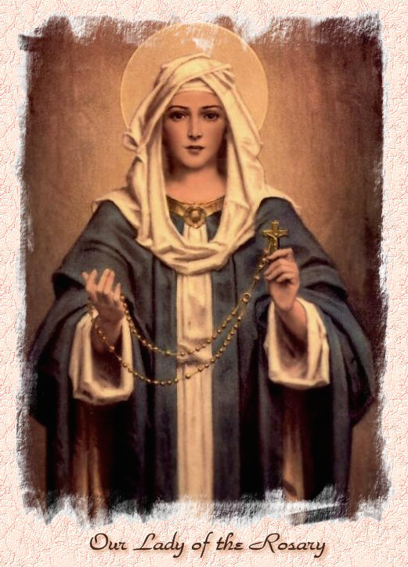

Our Lady of the Rosary  330a Burnt Oak Lane  Blackfen Sidcup  DA15 8LW  Tel. 020 8300 2697  Email: blackfen@rcaos.org.uk  Website: www.rcblackfen.org.uk  (Registered Charity 1173050)  Our Lady of the Rosary Primary School  Tel: 020 8850 4470 | Parish Team  Fr. Biju John  Our Priest  Vicki Rock  Parish Secretary  Office Hours  Mon, Wed, & Fri  9:00am-12:00pm  Website Co-ordinator

MASS TIMES:  SATURDAY VIGIL 6:00pm  SUNDAY 9:00am & 11am  CONFESSIONS:  Friday: 10.30am – 11.00am  Saturday: 5:20pm – 5:50pm  Marriage & Baptism by appointment only.  (Please ring the office to make an appointment) | EXPOSTION OF THE BL SACRAMENT:  Every Friday: 10.30 am to 11.00 am  CHILDREN’S LITURGY GROUP:  Every Sunday at 9am Mass  PRAYER GROUP:  Every Wednesday after 10am Mass  CHOIR PRACTICE:  After the 11am mass on Sunday  UCM:  Every First Tuesday Of the Month at 7.30pm  COFFEE MORNING:  After 11am Mass Sunday & 10am Thursday

Rotas for next week 8th/9th November 2025

Reader | Eucharistic Ministers | Church  Cleaners | Florist | Counters | Repository
Saturday  Sally  Sunday  9:00am  Osita  11:00am  Angel | Saturday  Bernadette  Joan  Mark  Sunday  9.00am  Henry  Chris  Carol-Ann  11:00am  Bernadette  Romeo  Rafael | Sarah | Sue  Edie | Julie  Jed | Saturday  Claire  Sunday  9:00am  Lynda  11:00am  Michelle

If you are unable to exercise your ministry, please arrange a replacement
Dear Friends & Parishners,
As we begin the month of November, I wish you all a grace-filled and fruitful time. This is the month when we lovingly remember and pray for all our loved ones who have gone before us into eternal life.
I take this opportunity to express my heartfelt gratitude to all our volunteers, benefactors, priests, and bishops who continue to support and build up our parish community. We also lovingly remember and give thanks for all those who have gone before us, who laid the foundations of faith and service in this parish.
May the Lord bless you and your families abundantly.
Have a blessed Sunday and a peaceful week ahead.
With prayers and best wishes,
Fr John

TODAY’S RESPONSE TO PSALM
REPONSE TO BIDDING PRAYER
READINGS FOR NEXT SUNDAY
All Saints Sunday
First Reading – Revelation 7:2-4,9-14
Second Reading – John 3:1-3
Gospel – Matthew 5:1-12a

NEXT WEEK’S 2nd COLLECTION
The Archbishop’s Appeal funds three key mission areas: Youth and Evangelization, Our Faith in Action, and Clergy Care and Formation.
2nd COLLECTIONS IN NOVEMBER
23rd Nov – Catholic Youth Services
30th Nov - Church Maintenance Fund

October Collections 20225

26/10/25 £506.75 1st Coll
£287.75 2nd Coll

Mass attendance 240
Thank you for your generosity.

PRAYERS FOR THE SICK
Colleen Moulinie, Christopher Browne,
Vivien Lobo, Alison Pearson, Lee Harris,
Stella Goodyear, Annie McQuillen, Mairead Rankin, Margaret Bayjou, Snr. Roy Howard, Alice Brand, Laurel, Susanna Brown, Gerard McDonagh, Josephine Treloar, Hilda Strangeway, Vincent Fionda, Howard Smith, Lisa, Morris Lacken and Mick Hannon. Please remember them in your prayers.

ARE YOU NEW IN THE PARISH?
Hello & Welcome!!!
Please register yourselves and your family. Registration and Gift Aid forms are at the back of the Church. Please introduce yourself to Fr John who will be delighted to welcome you.
GIFT AID INFORMATION,
Please remember that if you are a UK taxpayer you can Gift Aid your contribution to the Church. Forms are at the back of the church. Any enquiries, contact Julie at -
blackfengac@rcaos.org.uk. Thank you

DATES FOR YOUR DIARY
- Lunch Club & UCM Winter Warmer –
7th November 12:30-2pm. See posters for details.
- Prayer Group Special Meeting -
11th November 2pm.
- First Holy communion Registation –
11th November 7:30pm.
-Year Event Planning Meeting - Wednesday 12 November 7-9 pm.
- First Holy Communion Classes –
15th November 4:15pm.

NEWS
Pilgrim Walk in London This Monday
We warmly invite you to join our Pilgrim Walk this Monday. We will meet at 10:00 a.m. at Our Lady of the Rosary Parish. From there, we will take the 51 bus to Sidcup Station, then travel by train to London Bridge, where our walk will begin.
Missio Boxes
If you hold a red missio box could you please return it in the next 2 weeks at any of the weekend masses. If you could leave them in the sacrity please. Thank you.
Confirmation 2026
This will be open to all young people of the parish in year 8 and above. Forms are available at the back of the church or the office.
November Remembrance
Envelopes and lists are at the back of the Church for all the deceased members of your family and friends. If you are a Gift Aider please add your number to the envelope. Once you have completed your list, please put it in the basket on the Altar, with your offering. The basket will be available from Saturday 1st November.
Christian Meditation
Yoga–Christian Meditation sessions will start on Wednesday 5th November, at 7:00 p.m. in the Mini Hall. These guided sessions combine gentle postures with prayerful reflection, offering both spiritual peace and physical well-being. If you are interested in joining, please come along.
Padre Pio Prayer Group
On Tues 11th November at 2pm the Prayer Group are having a Special Meeting. There will be a short film on Fr Pio and his mit will be on the permises for Fr John to bless. This is a very special occasion for the Prayer Group and all are welcome to join them for this special event. It will be followed by refreshments.
Acutis Youth Group is opening!!
We are delighted to announce that our youth group will be opening on Wednesday 19th November 2025 and is open to all young people in years 7-11. The group will be a welcoming space for young people to meet up, socialise and have fun and will be open every Wednesday during term times from 7-9 pm. Membership costs just £5 a term. (This year due to the start date, fees will not be charged in the spring term). Members may bring ONE guest to individual sessions for £1. Dates for each term are as follows:
Autumn Term 19 November – 19 December (inc) Spring Term 14 January – 11 February (inc) and 25 February - 18 March (inc) Summer term 22 April – 20 May (inc) and 3 June – 8 July (inc)
To sign up complete and return a membership form after Mass today.
Induction Mass
The Induction Mass of Fr John will be celebrated on Friday, 28th November at 7:00 p.m., followed by a reception in the small hall. It is a diocesan tradition to hold an Induction Mass for a new priest when he officially takes charge of a parish. The ceremony is usually presided over by the Area Bishop or Episcopal Vicar. On this occasion, Canon Victor Darlington, Canon Edward Pereira, are expected to attend.
Please consider this a personal invitation to join us. It is a special occasion to pray for our parish and for your priest.
Book Launch: Pope Leo XIV – The New Era of Evangelisation On Sunday, 7th December, at around 11:45 a.m., the new book Pope Leo XIV – The New Era of Evangelisation will be launched in our parish by His Grace, Archbishop Kevin McDonald (Emeritus Archbishop of Southwark). The Rt Hon sir Stephen Timms, MP, will also be present on this occasion to share a few words and receive the first copy from the Archbishop.
Deceased Clergy Masses
Bexley Deanery - Friday 7th November at 12 noon. St. Lawrence of Canterbury, Sidcup.
Diocesan Mass - Tuesday 18th November
at 12.30pm at St. George’s Cathedral,
Westminster Bridge Road, SE1 7HY
Cemetery Blessings
-St. Pauline Church Yard 2nd November at 12:30 pm
-Hill View on 8th November at 11:30 am
- Brook Street on 9th November at 3:00 pm
- Friary Cemetery on 9th November (after the 8:30 Mass)
-Bexleyheath Cemetery on 9th November at 2:30 pm
-Kemnal Park Cemetery on 9th November at 2:00 pm
-Bostall Park and Sidcup together on 16th November at 2:00 pm.

