Mass Intentions for This Week

Sat  Sun | 25th Oct  26th Oct | 6:00 pm  9:00 am  11:00 am | Pro Populo  Ollie Maher R.I.P  Well-being of Howard Smith
Mon | 27th Oct | 10:00 am | Church Closed
Tue | 28th Oct | 10:00 am | Holy Souls
Wed | 29th Oct | 10:00 am | Holy Souls
Thu | 30th Oct | 10:00 am | Holy Souls
Fri | 31st Oct | 10:00 am | Nilda & Raffaele Alfano (Wedding Anniversary)
Sat  Sun | 1st Nov  2nd Nov  All Saints Day | 6:00 pm  9:00 am  11:00am | Deceased Relatives and Friends of Trill Family  Deceased Relatives & Friends of Alfano Family  Pro populo

OUR LADY OF THE ROSARY
30th Sunday in Ordinary Time
PARISH MASS BOOK YEAR C Page 155
Sunday 26th October 2025

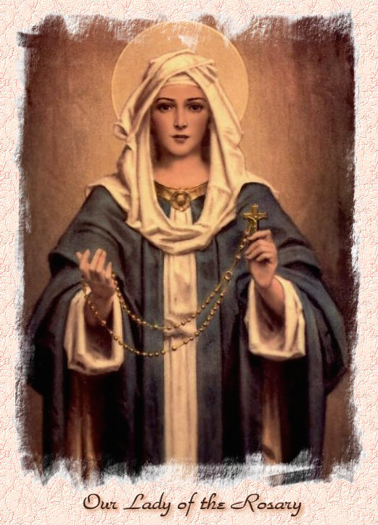

Our Lady of the Rosary  330a Burnt Oak Lane  Blackfen Sidcup  DA15 8LW  Tel. 020 8300 2697  Email: blackfen@rcaos.org.uk  Website: www.rcblackfen.org.uk  (Registered Charity 1173050)  Our Lady of the Rosary Primary School  Tel: 020 8850 4470 | Parish Team  Fr. Biju John  Our Priest  Vicki Rock  Parish Secretary  Office Hours  Mon, Wed, & Fri  9:00am-12:00pm  Website Co-ordinator

MASS TIMES:  SATURDAY VIGIL 6:00pm  SUNDAY 9:00am & 11am  CONFESSIONS:  Friday: 10.30am – 11.00am  Saturday: 5:20pm – 5:50pm  Marriage & Baptism by appointment only.  (Please ring the office to make an appointment) | EXPOSTION OF THE BL SACRAMENT:  Every Friday: 10.30 am to 11.00 am  CHILDREN’S LITURGY GROUP:  Every Sunday at 9am Mass  PRAYER GROUP:  Every Wednesday after 10am Mass  CHOIR PRACTICE:  After the 11am mass on Sunday  UCM:  Every First Tuesday Of the Month at 7.30pm  COFFEE MORNING:  After 11am Mass Sunday & 10am Thursday

Rotas for next week 1st/2nd November 2025

Reader | Eucharistic Ministers | Church  Cleaners | Florist | Counters | Repository
Saturday  Jo  Sunday  9:00am  Pauline  11:00am  Sue | Saturday  Mark  Eric  Jo  Sunday  9.00am  Carol-Ann  Christopher  11:00am  Justin  Vicki  Jude | Valerie  Michelle | Pat  Rita | Vicki  Ray  Peter | Saturday  Claire  Sunday  9:00am  Sarah  11:00am  Edie

If you are unable to exercise your ministry, please arrange a replacement
Dear Friends & Parishners,
As we approach the month of November, we lovingly remember our departed family and friends. It is a time of prayer, reflection, and renewal for our own souls, a reminder that in God, we remain united with both the living and the dead. Today’s parable calls us to embrace true humility and to rely not on our own merits, but on the boundless grace of God for our salvation.
I bless you with a beautiful and peaceful week ahead. May you stay warm, safe, and always close to the loving heart of God.
Fr. John

TODAY’S RESPONSE TO PSALM
The lowly one called, and the Lord heard him.
REPONSE TO BIDDING PRAYER
Lord graciously hear us.
READINGS FOR NEXT SUNDAY
31st Sunday in Ordinary Time
First Reading – Wisdom 11:22-12:2
Second Reading – Thessalonians 1:11-2:2
Gospel – Luke 19:1-10

THIS WEEKS 2nd COLLECTION
Church Maintenance Fund
2nd COLLECTIONS IN NOVEMBER
23rd Nov – Catholic Youth Services
30th Nov - Church Maintenance Fund

October Collections 2025

19/10/25 £672.08 1st Coll
£239.68 2nd Coll

Mass attendance 252
Thank you for your generosity.

PRAYERS FOR THE SICK
Colleen Moulinie, Christopher Browne,
Vivien Lobo, Alison Pearson, Lee Harris,

Stella Goodyear, Annie McQuillen, Mairead Rankin, Margaret Bayjou, Snr. Roy Howard, Alice Brand, Laurel, Susanna Brown, Gerard McDonagh, Josephine Treloar, Hilda Strangeway, Vincent Fionda, Howard Smith, Lisa, Morris Lacken and Mick Hannon. Please remember them in your prayers.

ARE YOU NEW IN THE PARISH?
Hello & Welcome!!!
Please register yourselves and your family. Registration and Gift Aid forms are at the back of the Church. Please introduce yourself to Fr John who will be delighted to welcome you.
GIFT AID INFORMATION,
Please remember that if you are a UK taxpayer you can Gift Aid your contribution to the Church. Forms are at the back of the church. Any enquiries, contact Julie at -
blackfengac@rcaos.org.uk. Thank you

DATES FOR YOUR DIARY
- Evangelisation Planning Meeting - Wednesday 29 October 7-9 pm
- Pilgrim Walk in London
Monday 3rd November.
- Lunch Club & UCM Winter Warmer –
7th November 12:30-2pm. See posters for details.
- First Holy communion Registation –
11th November 7:30pm.
-Year Event Planning Meeting - Wednesday 12 November 7-9 pm.
- First Holy Communion Classes –
15th November 4:15pm.

NEWS
New Parish Website
We warmly invite you to visit the site and explore the updates: https://rcblackfen.org.uk
Missio Boxes
If you hold a red missio box could you please return it in the next 2 weeks at any of the weekend masses. If you could leave them in the sacrity please. Thank you.
Evangelisation Volunteer
We are planning several initiatives for evangelisation in the parish. The major upcoming event will be the National Evangelisation Conference. If you would like to volunteer and be part of this important mission, please give your name to the parish office or talk to Fr. John
First Holy Communion
The enrolment forms for First Holy Communion are still available. If your child is baptised and aged 7 or above but has not yet received this beautiful sacrament, now is the time to register. Please collect the forms from the parish office or church porch.
Confirmation 2026
Forms are available from the parish office. This will be open to all young people of the parish in year 8 and above. The programme will start in February 2026 (TBC) with the Confirmation Mass towards the end of May 2026 (TBC).
November Remembrance
Envelopes and lists are at the back of the Church for all the deceased members of your family and friends. If you are a Gift Aider please add your number to the envelope. Once you have completed your list, please put it in the basket on the Altar, with your offering. The basket will be available from Saturday 1st November.
Pilgrim Walk in London
3rd November. The walk will take us through some of the traditional churches within or near the City of London, beginning from London Bridge.
Christian Meditation
Yoga–Christian Meditation sessions will begin on Wednesday 5th November, at 7:00 p.m. in the Mini Hall. These guided sessions combine gentle postures with prayerful reflection, offering both spiritual peace and physical well-being. If you are interested in joining, please give your name to the parish office. Donations are welcome, and all proceeds will go to a charity. Come and experience the harmony of body, mind, and spirit in the presence of God.
UCM Winter Warmer & Lunch Club
Will be holding a St Martin’s Day Lunch on Friday 7th November 12:30pm-2pm. Tickets and raffle tickets will be on sale after all weekend masses.
Induction Mass
The Induction Mass of Fr John will be celebrated on Friday, 28th November at 7:00 p.m., followed by a reception in the small hall. It is a diocesan tradition to hold an Induction Mass for a new priest when he officially takes charge of a parish. The ceremony is usually presided over by the Area Bishop or Episcopal Vicar. On this occasion, Canon Victor Darlington, Canon Edward Pereira, the Deanery priests, and other clergy are expected to attend.
Please make a note of the date in your diary and consider this a personal invitation to join us. It is a special occasion to pray for our parish and for your priest.
Book Launch: Pope Leo XIV – The New Era of Evangelisation
On Sunday, 7th December, at around 11:45 a.m., the new book Pope Leo XIV – The New Era of Evangelisation will be launched in our parish by His Grace, Archbishop Kevin McDonald (Emeritus Archbishop of Southwark).
The Rt Hon sir Stephen Timms, MP, will also be present on this occasion to share a few words and receive the first copy from the Archbishop. This book has been written as part of the mission of evangelisation, offering a new perspective that connects faith with the modern world, including themes such as artificial intelligence and global change.
Acutis Youth Group is opening!!
We are delighted to announce that our youth group will be opening on Wednesday 19 November 2025 and is open to all young people in years 7-11. The group will be for young people to meet up, socialise and have fun every Wednesday during term times from 7-9pm. Membership costs just £5 a term. More details and froms next week.
Parish Office
The office will be closed this Monday 27th , it will open again on Wednesday 29th.

