Mass Intentions for This Week

Sat  Sun | 15th Nov  16th Nov | 6:00 pm  9:00 am  11:00 am | Well-being of Breitner De Souza  Amelie & Elodie Trill & Family (Birthday)  Pro Populo
Mon | 17th Nov | 10:00 am | Church Closed
Tue | 18th Nov | 10:00 am | Erlindo Fulgercio (Birthday) R.I.P
Wed | 19th Nov | 10:00 am | David Meachem (Birthday) R.I.P
Thu | 20th Nov | 10:00 am | Finbar Healy R.I.P
Fri | 21st Nov | 10:00 am | Daniel Amusi R.I.P
Sat  Sun | 22nd Nov  23rd Nov | 6:00 pm  9:00 am  11:00am | Pro Populo  Well-being of Francis Tungdim Birthday  Adelina Pirolli R.I.P

OUR LADY OF THE ROSARY
33rd Sunday in Ordinary Time
PARISH MASS BOOK YEAR C Page 164
Sunday 16th November 2025

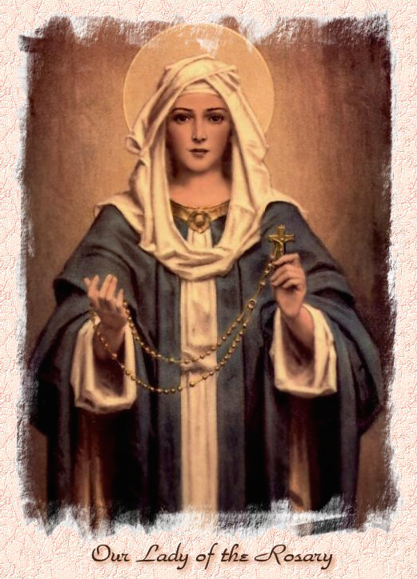

Our Lady of the Rosary  330a Burnt Oak Lane  Blackfen Sidcup  DA15 8LW  Tel. 020 8300 2697  Email: blackfen@rcaos.org.uk  Website: www.rcblackfen.org.uk  (Registered Charity 1173050)  Our Lady of the Rosary Primary School  Tel: 020 8850 4470 | Parish Team  Fr. Biju John  Our Priest  Vicki Rock  Parish Secretary  Office Hours  Mon, Wed, & Fri  9:00am-12:00pm  Website Co-ordinator  Yanet Devis

MASS TIMES:  SATURDAY VIGIL 6:00pm  SUNDAY 9:00am & 11am  CONFESSIONS:  Friday: 10.30am – 11.00am  Saturday: 5:20pm – 5:50pm  Marriage & Baptism by appointment only.  (Please ring the office to make an appointment) | EXPOSTION OF THE BL SACRAMENT:  Every Friday: 10.30 am to 11.00 am  CHILDREN’S LITURGY GROUP:  Every Sunday at 9am Mass  PRAYER GROUP:  Every Wednesday after 10am Mass  CHOIR PRACTICE:  After the 11am mass on Sunday  UCM:  Every First Tuesday Of the Month at 7.30pm  COFFEE MORNING:  After 11am Mass Sunday & 10am Thursday

Rotas for next week 22nd/23rd November 2025

Reader | Eucharistic Ministers | Church  Cleaners | Florist | Counters | Repository
Saturday  Pauline  Sunday  9:00am  Margaret T  11:00am  Daria | Saturday  Joan  Mark  Jo  Sunday  9.00am  Carol-Ann  Christopher  Henry  11:00am  Bernadette  Romeo  Rafael | Elsa | Pat  Rita | Louise  Michael | Saturday  Claire  Sunday  9:00am  Lynda  11:00am  Eloise

If you are unable to exercise your ministry, please arrange a replacement
Dear Friends & Parishners,
This Sunday we celebrate the World Day of the Poor, and next Sunday we will honour the Solemnity of Our Lord Jesus Christ, King of the Universe.
At this time, let us remember and pray for all those who struggle for their daily sustenance. Our spiritual goal is fulfilled only when we live in harmony with one another and care for the shared gifts of this world that God has entrusted to us.
We also look forward with great joy to the Induction Ceremony on Friday, 28th at 7 p.m. This is a parish celebration, officially welcoming and introducing your priest to the parish community.
It is your celebration, a moment of thanksgiving, unity, and shared faith. Let us come together as one family to mark this special occasion and to pray for God’s continued blessings upon our parish.
Fr John

TODAY’S RESPONSE TO PSALM
The Lord comes to judge the peoples with Fairness.
REPONSE TO BIDDING PRAYER
Hear our prayer.
READINGS FOR NEXT SUNDAY
Lord Jesus Christ, king of the Universe
First Reading – Samuel 5:1-3
Second Reading – Colossians 1:12-20
Gospel – Luke 23:35-43

ARE YOU NEW IN THE PARISH?
Hello & Welcome!!!
Please register yourselves and your family. Registration and Gift Aid forms are at the back of the Church. Please introduce yourself to Fr John who will be delighted to welcome you.

NEXT WEEK’S 2nd COLLECTION
Catholic Youth Services - National Youth

Sunday supports youth work in the diocese and beyond, especially the Southwark Catholic Youth Service.
2nd COLLECTIONS IN NOVEMBER
30th Nov - Church Maintenance Fund

November Collections 20225

9/11/25 £579.46 1st Coll
£286.77 2nd Coll

Mass attendance 224
Thank you for your generosity.

GIFT AID INFORMATION,
Please remember that if you are a UK taxpayer you can Gift Aid your contribution to the Church. Forms are at the back of the church. Any enquiries, contact Julie at -
blackfengac@rcaos.org.uk. Thank you

PRAYERS FOR THE SICK
Colleen Moulinie, Christopher Browne,
Vivien Lobo, Alison Pearson, Lee Harris,
Stella Goodyear, Annie McQuillen, Mairead Rankin, Margaret Bayjou, Snr. Roy Howard, Alice Brand, Laurel, Susanna Brown, Gerard McDonagh, Josephine Treloar, Hilda Strangeway, Vincent Fionda, Howard Smith, Lisa, Morris Lacken, Mick Hannon, Martin McDonagh, Gerald McDonagh and Annie McDonagh.
Please remember them in your prayers.

DATES FOR YOUR DIARY
-Youth Group Starts –
19th November 7pm-9pm
-Evangelistion meeting -
20th November 7pm.
-Yoga–Christian Meditation
Wednesdays 7pm
-First Holy Communion Class
22nd November 4:40pm

NEWS
We have various parish celebrations for First Holy Communion, Confirmation, RCIA, as
well as social events and exhibitions. If you would like to sponsor any of these programmes, either financially or by donating goods, please contact the parish office. RCIA Registration is now open. If you would like to begin or continue your journey of faith, you are warmly invited to join.
Please see Fr John.
Missio Boxes
If you hold a red missio box could you please return it in the next week. If you could leave them in the sacrity please. Thank you.
Confirmation 2026
This will be open to all young people of the parish in year 8 and above. Forms are available at the back of the church. Please return all forms by Monday 24th November. Thank you.
November Remembrance
Envelopes are at the back of the Church. If you are a Gift Aider please add your number to the envelope. Thank you.
Acutis Youth Group is opening!!
Wednesday 19th November 2025
Listening to feed back from the young of the Parish it has been decided to open up the Youth Group to children in years 5 & 6 as well as years 7-11. Please fill out a form and hand it back after mass or bring it along on Wednesday evening at 7pm. You will need a parent with you to sign up.
National Evangelisation Conference Summer 2026
Do you have an interest in AI or use AI in your daily work life? We need you! Please contact Jayne 07793 884137 or Claire 07958 790057 or join us at our next Committee meeting on Thurs 20th November at 7pm.
Induction Mass In the Catholic Church, an Induction Mass (also called the Mass of Induction or Installation Mass) is a special liturgical celebration during which a priest is formally introduced and entrusted with the pastoral care of a parish.
It is a moment of formal welcome, a symbol of unity, and a commitment between the priest and the parish community. During this celebration, the priest is officially commissioned to serve the people of God with faithfulness and pastoral charity. In response, the parishioners express their support, prayer, and collaboration.
There are also symbolic signs of pastoral responsibility, such as the handing over of the keys of the church and the signing of the parish register, marking the priest’s formal induction into the parish.
This special celebration will take place on Friday, 28th at 7 p.m. You are warmly invited to bring your family and friends and join us in welcoming and praying for your priest as he officially continues his ministry among you.
Book Launch: Pope Leo XIV – The New Era of Evangelisation
after the 11.a.m Mass, attended by His Grace, Archbishop Kevin McDonald (Emeritus Archbishop of Southwark) and The Rt Hon sir Stephen Timms, MP.
he book on Pope Leo XIV, Amor sed Amor (Love but Love) is also being used as a fundraising tool for our parish. If you would like to get a copy, please contact the parish office or tick your name on the sheet at the back of the church. The cost is £9.
Deceased Clergy Masses
Diocesan Mass - Tuesday 18th November
at 12.30pm at St. George’s Cathedral,
Cemetery Blessings
-Bostall Park and Sidcup together on 16th November at 2:00 pm.
Readers
Your Reading Rotas (which begin in January 26) are ready for collection from the small hall. Thank you.
Job Vancancy
St Catherine’s Catholic Girls School in Bexleyheath are seeking to appoint a highly effective and innovative Head of Art. For more information please visit
https://www.stccg.co.uk/Teaching-Vacancies/

