Mass Intentions for This Week

Sat  Sun | 22nd Nov  23rd Nov | 6:00 pm  9:00 am  11:00 am | Pro Populo  Well-being of Francis Tungdim Birthday  Adelina Pirolli R.I.P
Mon | 24th Nov | 10:00 am | Church Closed
Tue | 25th Nov | 10:00 am | Victor Herbert R.I.P
Wed | 26th Nov | 10:00 am | Holy Souls
Thu | 27th Nov | 10:00 am | Bridie McDonagh
Fri | 28th Nov | 7:00 pm | Fr John’s Induction Mass
Sat  Sun | 29th Nov  30th Nov | 6:00 pm  9:00 am  11:00am | Pro Populo  Well-being of Rosalind Tungdim Birthday  Deceased Relatives of Rock & Marsh Families

OUR LADY OF THE ROSARY

Lord Jesus Christ, King of the Universe
PARISH MASS BOOK YEAR C Page 167
Sunday 23rd November 2025

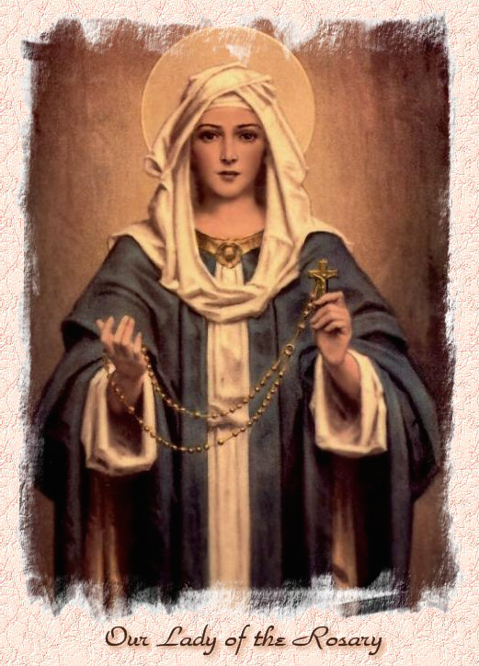

Our Lady of the Rosary  330a Burnt Oak Lane  Blackfen Sidcup  DA15 8LW  Tel. 020 8300 2697  Email: blackfen@rcaos.org.uk  Website: www.rcblackfen.org.uk  (Registered Charity 1173050)  Our Lady of the Rosary Primary School  Tel: 020 8850 4470 | Parish Team  Fr. Biju John  Our Priest  Vicki Rock  Parish Secretary  Office Hours  Mon, Wed, & Fri  9:00am-12:00pm  Yanet Devis  Website Co-ordinator

MASS TIMES:  SATURDAY VIGIL 6:00pm  SUNDAY 9:00am & 11am  CONFESSIONS:  Friday: 10.30am – 11.00am  Saturday: 5:20pm – 5:50pm  Marriage & Baptism by appointment only.  (Please ring the office to make an appointment) | EXPOSTION OF THE BL SACRAMENT:  Every Friday: 10.30 am to 11.00 am  CHILDREN’S LITURGY GROUP:  Every Sunday at 9am Mass  PRAYER GROUP:  Every Wednesday after 10am Mass  CHOIR PRACTICE:  After the 11am mass on Sunday  UCM:  Every First Tuesday Of the Month at 7.30pm  COFFEE MORNING:  After 11am Mass Sunday & 10am Thursday

Rotas for next week 29th/30th November 2025

Reader | Eucharistic Ministers | Church  Cleaners | Florist | Counters | Repository
Saturday  Jo  Sunday  9:00am  Margaret B  11:00am  Claire | Saturday  Bernadette  Mark  Eric  Sunday  9.00am  Christopher  Henry  Chris B  11:00am  Justin  Vicki  Jude | Valerie  Michelle | Margaret  Sue  Edie | Vicki  Ray  Peter | Saturday  Claire  Sunday  9:00am  Sarah  11:00am  Edie

If you are unable to exercise your ministry, please arrange a replacement
Dear Friends & Parishners,
This Sunday is the last Sunday of the liturgical year, and we also celebrate the feast of Christ, the King of the Universe. It is a joyful reminder that only Christ can bring us true and everlasting peace. As Catholics, we belong to the Kingdom of God, and we share in its mission to be bearers of peace in our world.
When Pope Leo XIV first stepped onto the balcony of St Peter’s and greeted the world with the words, “Peace be with you,” he echoed the greeting we offer one another at every Mass. It is more than a phrase; it is our calling.
May Christ our King reign in our hearts, our homes, and our parish.
Peace be with you.

TODAY’S RESPONSE TO PSALM
Let us go rejoicing to the house of the Lord.
REPONSE TO BIDDING PRAYER
Hear our prayer.
READINGS FOR NEXT SUNDAY
1st Sunday of Advent
First Reading – Isaiah 2:1-5
Second Reading – Romans 13:11-14a
Gospel – Matthew 24:37-44

ARE YOU NEW IN THE PARISH?
Hello & Welcome!!!
Please register yourselves and your family. Registration and Gift Aid forms are at the back of the Church. Please introduce yourself to Fr John who will be delighted to welcome you.

THIS WEEK’S 2nd COLLECTION
Catholic Youth Services - National Youth
Sunday supports youth work in the diocese and beyond, especially the Southwark Catholic Youth Service.

2nd COLLECTIONS IN NOVEMBER
30th Nov - Church Maintenance Fund

November Collections 20225

16/11/25 £539.02 1st Coll

Mass attendance 239
Thank you for your generosity.

GIFT AID INFORMATION,
Please remember that if you are a UK taxpayer you can Gift Aid your contribution to the Church. Forms are at the back of the church. Any enquiries, contact Julie at -
blackfengac@rcaos.org.uk. Thank you

PRAYERS FOR THE SICK
Colleen Moulinie, Christopher Browne,
Vivien Lobo, Alison Pearson, Lee Harris,
Stella Goodyear, Annie McQuillen, Mairead Rankin, Margaret Bayjou, Snr. Roy Howard, Alice Brand, Laurel, Susanna Brown, Gerard McDonagh, Josephine Treloar, Hilda Strangeway, Vincent Fionda, Howard Smith, Lisa, Morris Lacken, Mick Hannon, Martin McDonagh, Gerald McDonagh and Annie McDonagh.
Please remember them in your prayers.

DATES FOR THIS WEEK
-Yoga–Christian Meditation
Wednesday 7pm
-Youth Group
Wednesday 7-9pm
-Induction Mass
Friday 28th Nov 7pm
-First Holy Communion Class
29th Nov 4:40pm

Fr John’s Induction Mass
This special celebration will take place on Friday, 28th at 7 p.m. You are warmly invited to bring your family and friends and join us in welcoming and praying for your priest as he officially continues his ministry among you. This will be followed by a
celebration in the social club.
We ask kindly that you bring along a dish for a cold buffet for everyone to share, (no drinks). Thank you.
There will be no mass at 10am on this day.

NEWS
Knights of St Columba 90th Anniversary
On the Occasion of 90th Anniversary the Knights of St Columba, Welling Council 294 will be having a mass at St Stephen’s on Sunday 30th November 2025
11:30 AM in celebration. The Mass is being said for All Past and Present Brother's.
After the Mass service there will be refreshments in the Social Hall.
Book Launch: Pope Leo XIV – The New Era of Evangelisation
after the 11.a.m Mass, attended by His Grace, Archbishop Kevin McDonald (Emeritus Archbishop of Southwark) and The Rt Hon sir Stephen Timms, MP.
he book on Pope Leo XIV, Amor sed Amor (Love but Love) is also being used as a fundraising tool for our parish. If you would like to get a copy, please contact the parish office or tick your name on the sheet at the back of the church. The cost is £9.
Wooden Memory Plaques
These will go on sale from Tues 2rd Dec. Once the Christmas tree is up on the Altar the plaques for your loved ones will be placed on it.
UCM Christmas evening
The UCM will be holding a make your own Christmas table decoration on Tues 2nd Dec 7:30pm. All are welcome. Details to follow.
First Holy Communion
On Sat 13th Dec the Holy Communion Group will be having a Mulled wine and mince evening after 6pm Mass. All are welcome to join them.
Carol Service
On Thurs 18th Dec 7pm, the Choir will be holding there Carol Service. Followed by refreshments in the small hall. This is for the Whole family, where Santa will visit the Parish and we will draw our Christmas Raffle.
Christmas Raffle Donations
We are looking for donations of drink, biscuits, sweets, chocolates, and unused quality gifts for our Christmas Raffle. From next weekend 29th Nov the bin will be placed at the back of the church for donations, until Sunday 14th Dec.
RCIA Registration is now open. If you would like to begin or continue your journey of faith, you are warmly invited to join.
Please see Fr John.
Confirmation 2026
This will be open to all young people of the parish in year 8 and above. Forms are available at the back of the church. Please return all forms by Monday 24th November. Thank you.
November Remembrance
Envelopes are at the back of the Church. If you are a Gift Aider please add your number to the envelope. Thank you.
Acutis Youth Group
Is now open on Wednesday evenings 7-9pm, for children in years 5-11.
National Evangelisation Conference Summer 2026
Do you have an interest in AI or use AI in your daily work life? We need you! Please contact Jayne 07793 884137 or Claire 07958 790057
Tea & Coffee
There will now be tea & Coffee served in the small hall after 9am mass on Sundays.
Readers
Your Reading Rotas (which begin in January 26) are ready for collection from the small hall. Thank you.
Repository
Christmas stock is now available in the repository.
Thank You’s
-Kathleen, Andrea & Maureen for their work at Thursday Coffee Mornings and the donation to the Parish.
-To the Acutis Youth Ministry for their first successful week of the Youth Group.

