Mass Intentions for This Week

Sat  Sun | 29th Nov  30th Nov | 6:00 pm  9:00 am  11:00 am | Pro Populo  Well-being of Rosalind Tungdim Birthday  Deceased Relatives of Rock & Marsh Families
Mon | 1st Dec | 10:00 am | Church Closed
Tue | 2nd Dec | 10:00 am | Theresa Angel R.I.P
Wed | 3rd Dec | 10:00 am | St Francis Xavier
Thu | 4th Dec | 10:00 am | No Mass
Fri | 5th Dec | 7:00 pm | Theresa Angel R.I.P
Sat  Sun | 6th Dec  7th Dec | 6:00 pm  9:00 am  11:00am | Peter McPartlin R.I.P  Pro Populo  Eusebio Vaz (Birthday) R.I.P

OUR LADY OF THE ROSARY

1st Sunday of Advent
PARISH MASS BOOK YEAR A Page 82
Sunday 30th November 2025

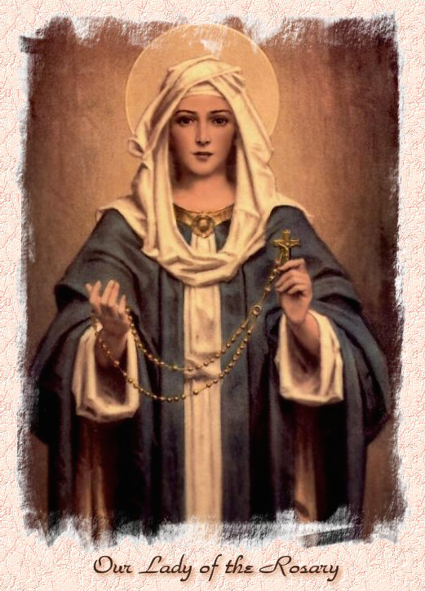

Our Lady of the Rosary  330a Burnt Oak Lane  Blackfen Sidcup  DA15 8LW  Tel. 020 8300 2697  Email: blackfen@rcaos.org.uk  Website: www.rcblackfen.org.uk  (Registered Charity 1173050)  Our Lady of the Rosary Primary School  Tel: 020 8850 4470 | Parish Team  Fr. Biju John  Our Priest  Vicki Rock  Parish Secretary  Office Hours  Mon, Wed, & Fri  9:00am-12:00pm  Yanet Devis  Website Co-ordinator

MASS TIMES:  SATURDAY VIGIL 6:00pm  SUNDAY 9:00am & 11am  CONFESSIONS:  Friday: 10.30am – 11.00am  Saturday: 5:20pm – 5:50pm  Marriage & Baptism by appointment only.  (Please ring the office to make an appointment) | EXPOSTION OF THE BL SACRAMENT:  Every Friday: 10.30 am to 11.00 am  CHILDREN’S LITURGY GROUP:  Every Sunday at 9am Mass  PRAYER GROUP:  Every Wednesday after 10am Mass  CHOIR PRACTICE:  After the 11am mass on Sunday  UCM:  Every First Tuesday Of the Month at 7.30pm  COFFEE MORNING:  After 11am Mass Sunday & 10am Thursday

Rotas for next week 6th/7th December 2025

Reader | Eucharistic Ministers | Church  Cleaners | Florist | Counters | Repository
Saturday  Sally  Sunday  9:00am  Angela  11:00am  Sue | Saturday  Joan  Mark  Sunday  9.00am  Henry  Chris B  Carol-Ann  11:00am  Bernadette  Romeo  Rafael | Sarah | Pat  Rita | Julie  Jed  Vicki | Saturday  Claire  Sunday  9:00am  Lynda  11:00am  Michelle

If you are unable to exercise your ministry, please arrange a replacement
Dear Friends & Parishners,
This Sunday marks the First Sunday of Advent, a sacred time that invites us to wait—with hope, with longing, and with love. We wait for Christmas, when Christ was born into our world, and we wait for Christ who comes to us now, gently knocking at the door of our hearts, seeking to enter and dwell within us.
Advent is a beautiful moment to pause and reflect on our communion with the living God. It is a season of expectation, of preparing our hearts, our homes, and our lives for His presence.
May this holy time of waiting inflame our hearts with love, strengthen our hope, and fill our homes with peace.
As we journey through Advent, may Christ draw us closer to Himself and renew in us the joy of His coming.
Wishing you a blessed and grace-filled Advent.

TODAY’S RESPONSE TO PSALM
Let us go rejoice to the house of the Lord.
REPONSE TO BIDDING PRAYER
Lord graciously hear us.
READINGS FOR NEXT SUNDAY
2nd Sunday of Advent
First Reading – Isaiah 11:1-10
Second Reading – Romans 15:4-9
Gospel – Matthew 3:1-12

ARE YOU NEW IN THE PARISH?
Hello & Welcome!!!
Please register yourselves and your family. Registration and Gift Aid forms are at the back of the Church. Please introduce yourself to Fr John who will be delighted to welcome you.

THIS WEEK’S 2nd COLLECTION
Church Maintenance Fund

2nd COLLECTIONS IN DECEMBER
14th Dec - Church Maintenance Fund

November Collections 20225

23/11/25 £466.63 1st Coll
£262.66 2nd Coll

Mass attendance 243
Thank you for your generosity.

GIFT AID INFORMATION,
Please remember that if you are a UK taxpayer you can Gift Aid your contribution to the Church. Forms are at the back of the church. Any enquiries, contact Julie at -
blackfengac@rcaos.org.uk. Thank you

PRAYERS FOR THE SICK
Colleen Moulinie, Christopher Browne,
Vivien Lobo, Alison Pearson, Lee Harris,
Stella Goodyear, Annie McQuillen, Mairead Rankin, Margaret Bayjou, Snr. Roy Howard, Alice Brand, Laurel, Susanna Brown, Gerard McDonagh, Josephine Treloar, Hilda Strangeway, Vincent Fionda, Howard Smith, Lisa, Morris Lacken, Mick Hannon, Martin McDonagh, Gerald McDonagh and Annie McDonagh.
Please remember them in your prayers.

DATES FOR THIS WEEK
-Yoga–Christian Meditation
Wednesday 7pm
-Youth Group
Wednesday 7-9pm
-First Holy Communion Class
Saturday 6th Dec 4:40pm
-Book Launch Mass
Sunday 7th December 11am

Book Launch: Pope Leo XIV – The New Era of Evangelisation
Sunday 7th December the 11.a.m Mass, attended by His Grace, Archbishop Kevin McDonald (Emeritus Archbishop of Southwark) and The Rt Hon sir Stephen

Timms, MP.
The book on Pope Leo XIV, Amor sed Amor (Love but Love) is also being used as a fundraising tool for our parish. If you would like to get a copy, these can be ordered on the day. There will be some available to buy for people visiting the parish.
Mass will be followed by a reception and book order/sale in the Parish Social Club. We ask that you all bring a plate of food for evryone to share as a light lunch at the reception after so that we may celebrate as a parish. Thank you.

NEWS
Knights of St Columba 90th Anniversary
On the Occasion of the 90th Anniversary of Knights of St Columba, Welling Council 294 will be having a mass at St Stephen’s on Sunday 30th November 2025
11:30 AM in celebration. The Mass is being said for All Past and Present Brother's.
After the Mass service there will be refreshments in the Social Hall.
Knights of St Columba Christmas Posters
The Knights of Welling Council 294
will be handing out to all Parishioners the KSC National ( KEEP CHRIST IN CHRISTMAS ) Poster, after all Masses the weekend of 13th & 14th December. They will also have a basket for Donations. Thank you for your support.
Wooden Memory Plaques
These will go on sale from Tues 2rd Dec. Once the Christmas tree is up on the Altar the plaques for your loved ones will be placed on it. The Plaques will be £1 each.
UCM Christmas evening
The UCM will be holding a make your own Christmas table decoration on Tues 2nd Dec. All are welcome. This will be in the small hall at 7:30pm. Anyone attending please bring with you a dish, chunky candle and
flowers for your display and greenery to share. Provided will be baubles, oasis, mince pies and a cuppa.
First Holy Communion
On Sat 13th Dec the Holy Communion Group will be having a Mulled wine and mince evening after 6pm Mass. All are welcome to join them.
Carol Service
On Thurs 18th Dec 7pm, the Choir will be holding there Carol Service. Followed by refreshments in the small hall. This is for the Whole family, where Santa will visit the Parish and we will draw our Christmas Raffle.
Christmas Raffle Donations
We are looking for donations of drink, biscuits, sweets, chocolates, and unused quality gifts for our Christmas Raffle. From next weekend 29th Nov the bin will be placed at the back of the church for donations, until Sunday 14th Dec.
Confirmation 2026
This will be open to all young people of the parish in year 8 and above. Forms are available at the back of the church. Please return all forms by Monday 24th November. Thank you.
Acutis Youth Group
Is now open on Wednesday evenings 7-9pm, for children in years 5-11. Please come along.
National Evangelisation Conference Summer 2026
Do you have an interest in AI or use AI in your daily work life? We need you! Please contact Jayne 07793 884137 or Claire 07958 790057
Readers
Your Reading Rotas (which begin in January 26) are ready for collection from the small hall. Thank you.
Repository
Christmas stock is now available in the repository.

