Mass Intentions for This Week

Sat  Sun | 8th Nov  9th Nov | 6:00 pm  9:00 am  11:00 am | Pro Populo  Holy Souls  Bernard Ellis (Birthday) R.I.P
Mon | 10th Nov | 10:00 am | Church Closed
Tue | 11th Nov | 10:00 am | Holy Souls
Wed | 12th Nov | 10:00 am | Thanks giving for favours received from Maureen Kuruppu
Thu | 13th Nov | 10:00 am | Deceased Relatives and Friends of Hedderman & Markey Families.
Fri | 14th Nov | 10:00 am | Elena Ferraris R.I.P
Sat  Sun | 15th Nov  16th Nov | 6:00 pm  9:00 am  11:00am | Well-being of Breitner De Souza  Amelie & Elodie Trill & Family (Birthday)  Pro Populo

OUR LADY OF THE ROSARY
The Dedication of the Lateran Basilica
PARISH MASS BOOK YEAR C Page 202
Sunday 9th November 2025

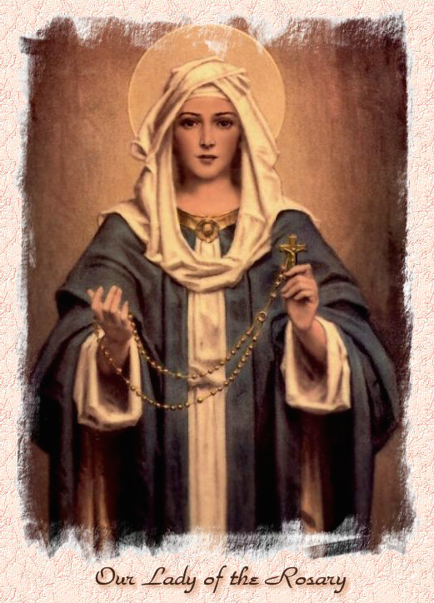

Our Lady of the Rosary  330a Burnt Oak Lane  Blackfen Sidcup  DA15 8LW  Tel. 020 8300 2697  Email: blackfen@rcaos.org.uk  Website: www.rcblackfen.org.uk  (Registered Charity 1173050)  Our Lady of the Rosary Primary School  Tel: 020 8850 4470 | Parish Team  Fr. Biju John  Our Priest  Vicki Rock  Parish Secretary  Office Hours  Mon, Wed, & Fri  9:00am-12:00pm  Website Co-ordinator  Yanet Devis

MASS TIMES:  SATURDAY VIGIL 6:00pm  SUNDAY 9:00am & 11am  CONFESSIONS:  Friday: 10.30am – 11.00am  Saturday: 5:20pm – 5:50pm  Marriage & Baptism by appointment only.  (Please ring the office to make an appointment) | EXPOSTION OF THE BL SACRAMENT:  Every Friday: 10.30 am to 11.00 am  CHILDREN’S LITURGY GROUP:  Every Sunday at 9am Mass  PRAYER GROUP:  Every Wednesday after 10am Mass  CHOIR PRACTICE:  After the 11am mass on Sunday  UCM:  Every First Tuesday Of the Month at 7.30pm  COFFEE MORNING:  After 11am Mass Sunday & 10am Thursday

Rotas for next week 15th/16th November 2025

Reader | Eucharistic Ministers | Church  Cleaners | Florist | Counters | Repository
Saturday  Bernadette  Sunday  9:00am  Henry  11:00am  Becky | Saturday  Eric  Jo  Bernadette  Sunday  9.00am  Christopher  Henry  Chris B  11:00am  Justin  Vicki  Jude | Nikki  Mary | Margaret  Rita | Maura  Sarah  Breitner | Saturday  Claire  Sunday  9:00am  Sarah  11:00am  Valerie

If you are unable to exercise your ministry, please arrange a replacement
Dear Friends & Parishners,
This Sunday, we celebrate the Dedication of the Lateran Basilica, the Mother and Head of all Churches. Built through the faith and sacrifice of many, it stands as a symbol of unity, love, and perseverance. As we cherish the fruits of their labour, let us too build our parish with the same devotion. People and priests may come and go, but what endures is the goodness we plant in God’s house.
With every blessing,
Fr. John

TODAY’S RESPONSE TO PSALM
The waters of a river give joy to God’s city, the holy place, the abode of the Most High.
REPONSE TO BIDDING PRAYER
Hear our prayer.
READINGS FOR NEXT SUNDAY
33rd Sunday in Ordinary Time
First Reading – Malachi 4:1-2a
Second Reading – Thessalonians 3:7-12
Gospel – Luke 21:5-19

THIS WEEK’S 2nd COLLECTION
The Archbishop’s Appeal funds three key mission areas: Youth and Evangelization, Our Faith in Action, and Clergy Care and Formation.
2nd COLLECTIONS IN NOVEMBER
23rd Nov – Catholic Youth Services
30th Nov - Church Maintenance Fund

November Collections 20225
2/11/25 £663.88 1st Coll
Dona machine for October £124.00
Mass attendance 219
Thank you for your generosity.

PRAYERS FOR THE SICK
Colleen Moulinie, Christopher Browne,
Vivien Lobo, Alison Pearson, Lee Harris,
Stella Goodyear, Annie McQuillen, Mairead Rankin, Margaret Bayjou, Snr. Roy Howard, Alice Brand, Laurel, Susanna Brown, Gerard McDonagh, Josephine Treloar, Hilda Strangeway, Vincent Fionda, Howard Smith, Lisa, Morris Lacken and Mick Hannon. Please remember them in your prayers.

ARE YOU NEW IN THE PARISH?
Hello & Welcome!!!
Please register yourselves and your family. Registration and Gift Aid forms are at the back of the Church. Please introduce yourself to Fr John who will be delighted to welcome you.
GIFT AID INFORMATION,
Please remember that if you are a UK taxpayer you can Gift Aid your contribution to the Church. Forms are at the back of the church. Any enquiries, contact Julie at -
blackfengac@rcaos.org.uk. Thank you

DATES FOR YOUR DIARY
- Prayer Group Special Meeting -
11th November 2pm.
-Year Event Planning Meeting - Wednesday 12 November 7-9 pm.
- First Holy Communion Classes –
15th November 4:15pm.
-Youth Group Starts –
19th November 7pm-9pm

NEWS
Missio Boxes
If you hold a red missio box could you please return it in the next week. If you could leave them in the sacrity please. Thank you.
First Holy Communion
The registation evening is on Tuesday 11th Nov at 7:30pm. If you have not handed in your registaton form please so so by end of Monday. Thank you.
Confirmation 2026
This will be open to all young people of the parish in year 8 and above. Forms are available at the back of the church. Please return all forms by Monday 24th November. Thank you.
November Remembrance
Envelopes are at the back of the Church for the deceased members of your family. If you
are a Gift Aider please add your number to the envelope. Please place it in the basket on the Altar, with your offering. Thank you.
Christian Meditation
Yoga–Christian Meditation sessions will meet on Wednesday’s, at 7:00 p.m. These sessions combine gentle postures with prayerful reflection, offering both spiritual and physical well-being. Donations will be for a charity.
Padre Pio Prayer Group
On Tues 11th November at 2pm the Prayer Group are having a Special Meeting. There will be a short film on Fr Pio and his mit will be on the permises for Fr John to bless. This is a very special occasion for the Prayer Group, all are welcome to join them for this special event. It will be followed by refreshments.
Claire’s London Marathon Fundraiser
for the Kent MS Therapy Centre - Friday 14th November 7:30pm. An evening of music from Ben and Claire sharing the story of Claire’s Dad, Patrick Connolly, living with MS, highlighting the amazing support the Centre provides. For tickets contact Claire 07958790056.
Acutis Youth Group is opening!!
Wednesday 19th November 2025 and is open to all young people in years 7-11. The group will be space for young people to meet up, socialise and have fun. It will be open Wednesday during term times from 7-9 pm. Membership costs just £5 a term. Members may bring ONE guest to individual sessions for £1. To sign up complete and return a membership form after Mass today.
National Evangelisation Conference Summer 2026
Do you have an interest in AI or use AI in your daily work life? We need you! Please contact Jayne 07793 884137 or Claire 07958 790057 or join us at our next Committee meeting on Thurs 20th November at 7pm.
Induction Mass
The Induction Mass of Fr John will be celebrated on Friday, 28th November at 7:00 p.m., followed by a reception in the small hall. It is a diocesan tradition to hold an Induction Mass for a new priest when he officially takes charge of a parish. The ceremony is usually presided over by the Area Bishop or Episcopal Vicar. On this occasion, Canon Victor Darlington, Canon Edward Pereira, are expected to attend.
Please consider this a personal invitation to join us. It is a special occasion to pray for our parish and for your priest.
Book Launch: Pope Leo XIV – The New Era of Evangelisation On Sunday, 7th December, at around 11:45 a.m., the new book Pope Leo XIV – The New Era of Evangelisation will be launched in our parish by His Grace, Archbishop Kevin McDonald & The Rt Hon Sir Stephen Timms, MP, will also be present to share a few words and receive the first copy from the Archbishop.
Pilgrimage to Rome
As the Jubilee Year draws to a close, I will be making a pilgrimage to Rome from December 8th to 12th. If anyone would like to join, please let me know by today, as this was not previously planned. I can arrange for a few people to attend the Papal General Audience. Please note that lodging in Rome will be difficult to find in December and January as the Jubilee comes to an end, so kindly give your name today.
Deceased Clergy Masses
Diocesan Mass - Tuesday 18th November
at 12.30pm at St. George’s Cathedral,
Westminster Bridge Road, SE1 7HY
Cemetery Blessings
- Brook Street on 9th November at 3:00 pm
- Friary Cemetery on 9th November (after the 8:30 Mass)
-Bexleyheath Cemetery on 9th November at 2:30 pm
-Kemnal Park Cemetery on 9th November at 2:00 pm
-Bostall Park and Sidcup together on 16th November at 2:00 pm.
RCIA registration is now open. If you would like to begin or continue your journey of faith, you are warmly invited to join.

