Mass Intentions for This Week

Sat  Sun | 13th Dec  14th Dec | 6:00 pm  9:00 am  11:00 am | Pro Populo  Felix Tungdim Birthday  Marie-Louise Pirolli R.I.P
Mon | 15th Dec | 10:00 am | Church Closed
Tue | 16th Dec | 10:00 am | Well-being of Samantha & Paul Murphy & Family
Wed | 17th Dec | 10:00 am | Gladys Smith (Anniversary) R.I.P
Thu | 18th Dec | 10:00 am  7:00 pm | Tony McPartland R.I.P  Carol Service
Fri | 19th Dec | 10:00 am | Well-Being of Christine
Sat  Sun | 20th Dec  21st Dec | 10:00 am  6:00 pm  9:00 am  11:00am | Anionting Mass  Pro Populo  Theresa Angel R.I.P  Leslie Thomas R.I.P

OUR LADY OF THE ROSARY
3rd Sunday of Advent
PARISH MASS BOOK YEAR A Page 88
Sunday 14th December 2025

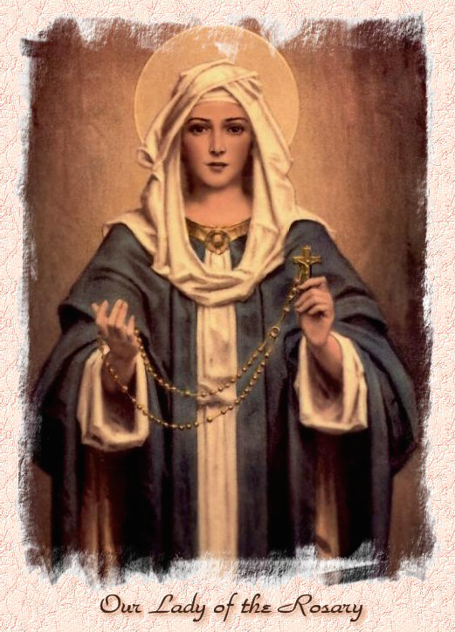

Our Lady of the Rosary  330a Burnt Oak Lane  Blackfen Sidcup  DA15 8LW  Tel. 020 8300 2697  Email: blackfen@rcaos.org.uk  Website: www.rcblackfen.org.uk  (Registered Charity 1173050)  Our Lady of the Rosary Primary School  Tel: 020 8850 4470 | Parish Team  Fr. Biju John  Our Priest  Vicki Rock  Parish Secretary  Office Hours  Mon, Wed, & Fri  9:00am-12:00pm  Yanet Devis  Website Co-ordinator

MASS TIMES:  SATURDAY VIGIL 6:00pm  SUNDAY 9:00am & 11am  CONFESSIONS:  Friday: 10.30am – 11.00am  Saturday: 5:20pm – 5:50pm  Marriage & Baptism by appointment only.  (Please ring the office to make an appointment) | EXPOSTION OF THE BL SACRAMENT:  Every Friday: 10.30 am to 11.00 am  CHILDREN’S LITURGY GROUP:  Every Sunday at 9am Mass  PRAYER GROUP:  Every Wednesday after 10am Mass  CHOIR PRACTICE:  After the 11am mass on Sunday  UCM:  Every First Tuesday Of the Month at 7.30pm  COFFEE MORNING:  After 11am Mass Sunday & 10am Thursday

Rotas for next week 20th/21st December 2025

Reader | Eucharistic Ministers | Church  Cleaners | Florist | Counters | Repository
Saturday  Pauline  Sunday  9:00am  Osita  11:00am  Becky | Saturday  Eric  Joan  Mark  Sunday  9.00am  Carol-Ann  Mateusz  Christopher  11:00am  Bernadette  Romeo  Vicki | Elsa | Volunteers | Louise  Michael  Martine | Saturday  Claire  Sunday  9:00am  Lynda  11:00am  Eloise

If you are unable to exercise your ministry, please arrange a replacement
Dear Friends & Parishners,
This is the third week of Advent, and we are very close to celebrating Christmas. It is a time that invites us to open our minds and hearts to the flame of God’s love.
In Rome, we have seen thousands of pilgrims—some seeking a new light, others simply wanting to be present, and still others renewing their faith. Yet all of them are united by a purpose.
This is also the journey of our own lives. We are here for a purpose. To fulfil it, and to direct our lives toward what God desires for us, we must constantly renew ourselves so that we may encounter God, who is supreme love.
God Bless
Fr John

THANK YOU
Thank you to everyone that came and took part in the book launch. To Jayne and the choir, Alex and all who took part behind the scenes, thank you. It was nice to see so many of you stay for the social event in the Parish Club after and for everyone’s generosity in providing food. If you did not get a copy of the book please contact the office before Thursday 18th December either in person or by email blackfen@rcaos.org.uk with your order and payment before we do another order. Thank you.

TODAY’S RESPONSE TO PSALM
Come, Lord, and save us.
REPONSE TO BIDDING PRAYER
Hear our prayer.
READINGS FOR NEXT SUNDAY
4th Sunday of Advent
First Reading – Isaiah 7:10-14

Second Reading – Romans 1:1-7
Gospel – Matthew 1:18-24

ARE YOU NEW IN THE PARISH?
Hello & Welcome!!!
Please register yourselves and your family. Registration and Gift Aid forms are at the back of the Church. Please introduce yourself to Fr John who will be delighted to welcome you.

THIS WEEK’S 2nd COLLECTIONS
Church Maintenance Fund

December Collections 20225

7/12/25 £580.37 1st Coll

Mass attendance 237
Thank you for your generosity.

GIFT AID INFORMATION,
Please remember that if you are a UK taxpayer you can Gift Aid your contribution to the Church. Forms are at the back of the church. Any enquiries, contact Julie at -
blackfengac@rcaos.org.uk. Thank you

PRAYERS FOR THE SICK
Colleen Moulinie, Christopher Browne,
Vivien Lobo, Alison Pearson, Lee Harris, Stella Goodyear, Annie McQuillen, Mairead Rankin, Margaret Bayjou, Snr. Roy Howard, Alice Brand, Laurel, Susanna Brown, Gerard McDonagh, Josephine Treloar, Hilda Strangeway, Vincent Fionda, Howard Smith, Lisa, Morris Lacken, Mick Hannon, Martin McDonagh, Gerald McDonagh and Annie McDonagh.
Please remember them in your prayers.

MASS INTENTIONS
Mass intention are to be booked through the parish office. Anniversary masses should be booked in advance. There are envelopes at the back of the church for this. Please make sure you add your name and phone number in case your requested mass is not available.
Thank you.

DATES FOR THIS WEEK
-Yoga–Christian Meditation
Wednesday 7pm
-Youth Group
Wednesday 7-9pm (Children years 5-11)
-Carol Service
Thursday 18th December 7pm.
-Evangelisation Committee Meeting
Saturday 20thn December 3:30pm
-FHC Class
Saturday 20th December 4:40pm

NEWS
Christmas Offerings
The offerings at Christmas are your gift to your Parish Priest. This makes up part of their annual income. Priests in England and Wales are not paid, so Easter and Christmas collections are their main source of income. Envelopes for this are at the back of the Church. If you are going away this Christmas, you can make your offerings in advance. If you are Gift Aid registered please use your envelopes and that way, the parish can claim back the tax. It has also been added to the contactless machine at the back of the church under Christmas Offertory.
Thank you so much for your kindness and generosity at this time.
Christmas Card Mass Times
Please find at the back of the church the Christmas card with the mass times on for the 3 week Christmas and New Year period
Wooden Memory Plaques
Are on now sale. Once the Christmas tree is up on the Altar the plaques for your loved ones names will be placed on it. The Plaques
are £1 each and can be found at the back of the church. (Please don’t take the pens). Thank you.
Knights of St Columba Christmas Posters
The Knights of Welling Council 294
will be handing out to all Parishioners the KSC National (KEEP CHRIST IN
CHRISTMAS ) Poster, after all Masses this weekend. They will also have a basket for Donations. Thank you for your support.
Christmas Raffle Donations
We are still looking for donations of drink, biscuits, sweets, chocolates, and unused quality gifts for our Christmas Raffle. This will finish today. Thank you
Confirmation 2026
This will be open to all young people of the parish in year 8 and above. Forms are available at the back of the church. Please return all forms by today Sunday 14th December. Thank you.
Carol Service
On Thursday 18th December @ 7pm, the Choir will be holding there Carol Service. Followed by refreshments in the small hall. This is for the Whole family, where Santa will visit the Parish and we will draw our Christmas Raffle.Tickets for the Carol Concert are £3.00 and will be on sale after every weekend mass along with the raffle tickets.
Evangelisation Committee
Our next meeting will be held on Saturday 20th December at 3:30pm in the Small Hall.
Will are still looking for a few more members to join us. If you have an interest in AI or use it with work or an interest in Evangelisation WE NEED YOU! please come along to our next meeting to find out about us, or contact Jayne 07793 884137 or Claire 07958 790057.
Padre Pio Prayer Group
Are taking there Christmas break and will return on Wednesday 7th January after 11am Mass. This prayer group is open to all, so please feel free to come along and join.

