Mass Intentions for This Week

Sat  Sun | 20th Dec  21st Dec | 10:00 am  6:00 pm  9:00 am  11:00 am | Anionting Mass  Pro Populo  Theresa Angel R.I.P  Leslie Thomas R.I.P
Mon | 22nd Dec | 10:00 am | Church Closed
Tue | 23rd Dec | 10:00 am | Holy Souls
Wed | 24th Dec | 6:00 pm  9:00 pm | Patrick Sullivan R.I.P  Kathleen & Albert Lynch R.I.P
Thu | 25th Dec | 11:00 am | Well-being of D’Silva Family
Fri | 26th Dec | 10:00 am | Well-being of Fr John
Sat  Sun | 27th Dec  28th Dec | 6:00 pm  9:00 am  11:00am | Holy Souls  Pro Populo  David Meachem R.I.P

OUR LADY OF THE ROSARY
4th Sunday of Advent
PARISH MASS BOOK YEAR A Page 90
Sunday 21st December 2025

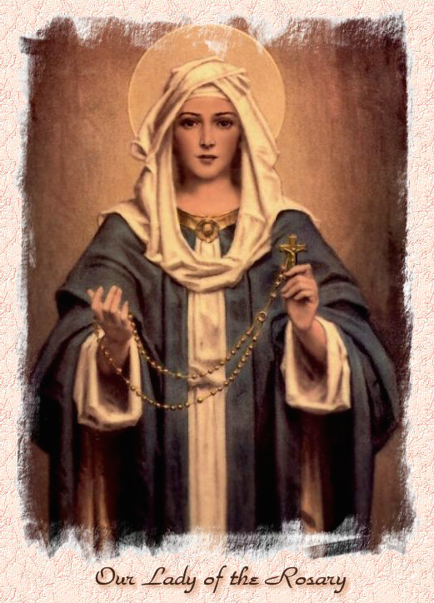

Our Lady of the Rosary  330a Burnt Oak Lane  Blackfen Sidcup  DA15 8LW  Tel. 020 8300 2697  Email: blackfen@rcaos.org.uk  Website: www.rcblackfen.org.uk  (Registered Charity 1173050)  Our Lady of the Rosary Primary School  Tel: 020 8850 4470 | Parish Team  Fr. Biju John  Our Priest  Vicki Rock  Parish Secretary  Office Hours  Mon, Wed, & Fri  9:00am-12:00pm  Yanet Devis  Website Co-ordinator

MASS TIMES:  SATURDAY VIGIL 6:00pm  SUNDAY 9:00am & 11am  CONFESSIONS:  Friday: 10.30am – 11.00am  Saturday: 5:20pm – 5:50pm  Marriage & Baptism by appointment only.  (Please ring the office to make an appointment) | EXPOSTION OF THE BL SACRAMENT:  Every Friday: 10.30 am to 11.00 am  CHILDREN’S LITURGY GROUP:  Every Sunday at 9am Mass  PRAYER GROUP:  Every Wednesday after 10am Mass  CHOIR PRACTICE:  After the 11am mass on Sunday  UCM:  Every First Tuesday Of the Month at 7.30pm  COFFEE MORNING:  After 11am Mass Sunday & 10am Thursday

Rotas for next week 27th/28th December 2025

Reader | Eucharistic Ministers | Church  Cleaners | Florist | Counters | Repository
Saturday  Jo  Sunday  9:00am  Henry  11:00am  Daria | Saturday  Jo  Bernadette  Eric  Sunday  9.00am  Henry  Chris  Carol-Ann  11:00am  Bernadette  Romeo | Valerie  Michelle | Volunteers | Louise  Ray  Peter | Saturday  Claire  Sunday  9:00am  Sarah  11:00am  Edie

If you are unable to exercise your ministry, please arrange a replacement
Dear Friends & Parishners,
The Fourth Sunday of Advent reminds us of a wonderful gift: “The Virgin will conceive and bear a son, and he will be called Emmanuel”—God with us—who comes to redeem us from our sins and to save us.
My dear friends, this week offers us a golden opportunity to go to confession and be reconciled with God and with one another, so that the saving work of God may truly take effect in our lives. I urge you to go to confession, not necessarily in our own parish, as there are many churches around us, but please make sure that you take this opportunity.

I wish you and your family a happy Christmas and a blessed New Year.
You are most welcome to bring your family members, friends, and neighbours to our Christmas celebration and the Holy Mass.
Let us make this Christmas a special one for all of us.
May God bless you all.
Fr John

TODAY’S RESPONSE TO PSALM
Let the Lord enter: he is the king of glory.
REPONSE TO BIDDING PRAYER
Hear our prayer.
READINGS FOR NEXT SUNDAY
The Nativity of the Lord 25th Dec
6pm & 9pm Mass page 95
11am Mass page 103
The Holy Family of Jesus, Mary & Joseph 28th Dec
First Reading – Sirach 3:2-6, 12-14
Second Reading – Colossians 3:12-21
Gospel – Matthew 2:13-15, 19-23

ARE YOU NEW IN THE PARISH?
Hello & Welcome!!!
Please register yourselves and your family. Registration and Gift Aid forms are at the back of the Church. Please introduce yourself to Fr John who will be delighted to welcome you.

December Collections 20225

14/12/25 £719.48 1st Coll
£252.72 2nd Coll

Mass attendance 205
Thank you for your generosity.

GIFT AID INFORMATION,
Please remember that if you are a UK taxpayer you can Gift Aid your contribution to the Church. Forms are at the back of the church. Any enquiries, contact Julie at -
blackfengac@rcaos.org.uk. Thank you

PRAYERS FOR THE SICK
Colleen Moulinie, Christopher Browne,
Vivien Lobo, Alison Pearson, Lee Harris, Stella Goodyear, Annie McQuillen, Mairead Rankin, Margaret Bayjou, Snr. Roy Howard, Alice Brand, Laurel, Susanna Brown, Gerard McDonagh, Josephine Treloar, Hilda Strangeway, Vincent Fionda, Howard Smith, Lisa, Morris Lacken, Mick Hannon, Martin McDonagh, Gerald McDonagh and Annie McDonagh.
Please remember them in your prayers.

MASS INTENTIONS
Mass intention are to be booked through the parish office. Anniversary masses should be booked in advance. There are envelopes at the back of the church for this. Please make sure you add your name and phone number in case your requested mass is not available.
Thank you.

Christmas Preparation
-Confession Times
Tuesday 23rd Dec 10.30 to 11.30 a.m
Wednesday 24th Dec 7 pm to 8 p.m
Christmas Masses
Christmas eve
5:30pm Carols/Nativity
6:00pm & 9:00pm Mass
Christmas day 11:00am.

NEWS
Christmas Offerings
The offerings at Christmas are your gift to your Parish Priest. This makes up part of their annual income. Priests in England and Wales are not paid, so Easter and Christmas collections are their main source of income. Envelopes for this are at the back of the Church. If you are going away this Christmas, you can make your offerings in advance. If you are Gift Aid registered please use your envelopes and that way, the parish can claim back the tax. It has also been added to the contactless machine at the back of the church under Christmas Offertory.
Thank you so much for your kindness and generosity at this time.
Carol Concert
On Thursday night we had our carol concert. It was a lovely evening with carols and the christmas story followed by drinks, Santa and a raffle. Thank you to everyone who came along, but a special thank you to Jayne and the Choir with the help of a few others for all the hard work they have put in to perform such a lovely concert to us all.
Thank you to everyone who donated prizes for the raffle, your generosity is always above and beyond. Unclaimed prizes…..
Brown ticket 191-195, yellow ticket 136-140, brown ticket 6-10, yellow ticket 76-80, brown ticket 136-140.
THANK YOU
Thank you to everyone who has helped decorate the church and the hall for Christmas. The flower team have spent many hours decorating the church this week and Raffaele and his team have done a wonderful job of decorating the hall for our parish events.
Missio
A big thank you to everybody who handed in their `Missio boxes this autumn, we have raised £247.93 for their work.
Please remember to collect your red boxes from the back of the church. Thank you for your continued support.
Book Launch
Thank you for your everyones help at the book launch and for purchasing the books.
We are pleased to share that we have raised £133.00 for the parish. The retail price of the book is £13.45; however, it was sold at a discounted price of £9. From each copy sold, 22.22% of the proceeds were contributed to our parish. We kindly ask you to share the book link with your friends, relatives, and on social media, and to consider writing a review using the links provided.

Archbishop Kevin and Bishop Pat have conveyed their appreciation to our parish.
HAPPY CHRISTMAS
Fr John, Vicki and all the team at Our Lady of the Rosary, Blackfen, would like to wish all Parishioners a very Merry and Peaceful Christmas.
PLEASE NOTE
This week we have had CCTV installed in the Church, the Sacristy and the Small Hall.
This is for security and safety of the parish and the parishioners.

