Mass Intentions for This Week

Sat  Sun | 6th Dec  7th Dec | 6:00 pm  9:00 am  11:00 am | Peter McPartlin R.I.P  Pro Populo  Eusebio Vaz (Birthday) R.I.P
Mon | 8th Dec | 10:00 am | Church Closed
Tue | 9th Dec | 10:00 am | No Mass
Wed | 10th Dec | 10:00 am | Eucharistic Service
Thu | 11th Dec | 10:00 am | No Mass
Fri | 12th Dec | 10:00 am | Well-being of Sister Teresa
Sat  Sun | 13th Dec  14th Dec | 6:00 pm  9:00 am  11:00am | Pro Populo  Felix Tungdim Birthday  Marie-Louise Pirolli R.I.P

OUR LADY OF THE ROSARY
2nd Sunday of Advent
PARISH MASS BOOK YEAR A Page 85
Sunday 7th December 2025

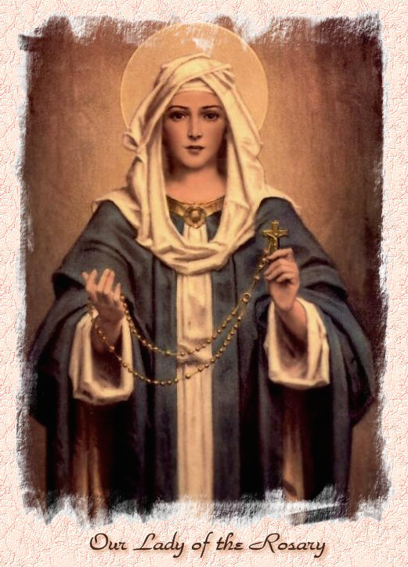

Our Lady of the Rosary  330a Burnt Oak Lane  Blackfen Sidcup  DA15 8LW  Tel. 020 8300 2697  Email: blackfen@rcaos.org.uk  Website: www.rcblackfen.org.uk  (Registered Charity 1173050)  Our Lady of the Rosary Primary School  Tel: 020 8850 4470 | Parish Team  Fr. Biju John  Our Priest  Vicki Rock  Parish Secretary  Office Hours  Mon, Wed, & Fri  9:00am-12:00pm  Yanet Devis  Website Co-ordinator

MASS TIMES:  SATURDAY VIGIL 6:00pm  SUNDAY 9:00am & 11am  CONFESSIONS:  Friday: 10.30am – 11.00am  Saturday: 5:20pm – 5:50pm  Marriage & Baptism by appointment only.  (Please ring the office to make an appointment) | EXPOSTION OF THE BL SACRAMENT:  Every Friday: 10.30 am to 11.00 am  CHILDREN’S LITURGY GROUP:  Every Sunday at 9am Mass  PRAYER GROUP:  Every Wednesday after 10am Mass  CHOIR PRACTICE:  After the 11am mass on Sunday  UCM:  Every First Tuesday Of the Month at 7.30pm  COFFEE MORNING:  After 11am Mass Sunday & 10am Thursday

Rotas for next week 13th/14th December 2025

Reader | Eucharistic Ministers | Church  Cleaners | Florist | Counters | Repository
Saturday  Bernadette  Sunday  9:00am  Pauline  11:00am  Angel | Saturday  Bernadette  Eric  Joan  Sunday  9.00am  Christopher  Henry  Chris B  11:00am  Justin  Vicki  Jude | Nikki  Mary | Sue  Edie | Maura  Sarah  Breitner | Saturday  Claire  Sunday  9:00am  Sarah  11:00am  Valerie

If you are unable to exercise your ministry, please arrange a replacement
Dear Friends & Parishners,
As we enter the Second Week of Advent, we are reminded that the joyful celebration of Christmas is drawing near. Yet Advent is not only about preparing for the birth of Christ in Bethlehem, it is also about preparing our hearts to meet Christ in our own lives.
This holy Advent invites us to reflect on the truth that our entire life is a journey of waiting, hoping, and longing for the Lord. One day, in God’s time, we will meet Christ face to face. Therefore, the Church calls us, just as John the Baptist cried out in the wilderness, to “prepare the way of the Lord” by renewing our hearts, deepening our faith, and embracing God’s love.
As we light the second candle of Advent, may its gentle flame fill you with peace, joy, and hopeful expectation.
I wish you all the blessings and joy of this Second Week of Advent.
God Bless
Fr John

TODAY’S RESPONSE TO PSALM
In his days shall justice flourish, and great peace for ever.
REPONSE TO BIDDING PRAYER
Hear our prayer.
READINGS FOR NEXT SUNDAY
3rd Sunday of Advent
First Reading – Isaiah 35:1-6a, 10
Second Reading – James 5:7-10
Gospel – Matthew 11:2-11

ARE YOU NEW IN THE PARISH?
Hello & Welcome!!!
Please register yourselves and your family. Registration and Gift Aid forms are at the back of the Church. Please introduce yourself to Fr John who will be delighted to welcome you.

2nd COLLECTIONS IN DECEMBER
14th Dec - Church Maintenance Fund

November Collections 20225

30/11/25 £466.63 1st Coll
£262.66 2nd Coll

Dona Machine for Nov £217.50

Mass attendance 222
Thank you for your generosity.

GIFT AID INFORMATION,
Please remember that if you are a UK taxpayer you can Gift Aid your contribution to the Church. Forms are at the back of the church. Any enquiries, contact Julie at -
blackfengac@rcaos.org.uk. Thank you

PRAYERS FOR THE SICK
Colleen Moulinie, Christopher Browne,
Vivien Lobo, Alison Pearson, Lee Harris, Stella Goodyear, Annie McQuillen, Mairead Rankin, Margaret Bayjou, Snr. Roy Howard, Alice Brand, Laurel, Susanna Brown, Gerard McDonagh, Josephine Treloar, Hilda Strangeway, Vincent Fionda, Howard Smith, Lisa, Morris Lacken, Mick Hannon, Martin McDonagh, Gerald McDonagh and Annie McDonagh.
Please remember them in your prayers.

WELCOME TODAY We warmly welcome Archbishop Kevin McDonald (Emeritus Archbishop of Southwark), Bishop Pat Lynch (Emeritus Auxiliary Bishop of Southwark), and Hon. Sir Stephen Timms, MP, for the release of the book Pope Leo XIV: Amor sed Amor , Love but Love.
We also extend a heartfelt welcome to our guests from various parishes who have joined us to share in our joy.

DATES FOR THIS WEEK
-Yoga–Christian Meditation
Wednesday 7pm
-Youth Group
Wednesday 7-9pm (Children years 5-11)
-First Holy Communion Class
Saturday 13th Dec 4:40pm
-FHC Mulled wine evening
Saturday 13th after 6pm Mass

NEWS
Knights of St Columba Christmas Posters
The Knights of Welling Council 294
will be handing out to all Parishioners the KSC National (KEEP CHRIST IN
CHRISTMAS ) Poster, after all Masses the weekend of 13th & 14th December. They will also have a basket for Donations. Thank you for your support.
Wooden Memory Plaques
Are on now sale. Once the Christmas tree is up on the Altar the plaques for your loved ones names will be placed on it. The Plaques are £1 each and can be found at the back of the church.
UCM Christmas Evening
Thank you to all who turned up on Tuesday

night for our make a decoration evening. It was very well attended and everyone seem to have an enjoyable evening.
First Holy Communion
On Sat 13th Dec there will be a Mulled wine and mince pie evening after 6pm Mass. This is for everyone in the parish.
Carol Service
On Thurs 18th Dec 7pm, the Choir will be holding there Carol Service. Followed by refreshments in the small hall. This is for the Whole family, where Santa will visit the Parish and we will draw our Christmas Raffle.Tickets for the Carol Concert are £2.00 and will be on sale after every weekend mass from this weeken along with the raffle tickets.
Christmas Raffle Donations
We are still looking for donations of drink, biscuits, sweets, chocolates, and unused quality gifts for our Christmas Raffle. The bin will be at the back of the church for donations, until Sunday 14th Dec.
Confirmation 2026
This will be open to all young people of the parish in year 8 and above. Forms are available at the back of the church. Please return all forms by Sunday 14th December. Thank you.
Hall Hire
Our parish has a dedicated Fundraising Team and Events Team who oversee all parish events and fundraising activities.
If you wish to hire the parish hall for any celebration with your family or friends, please contact the Parish Office to check availability and to learn about the hall-hire procedure.
As we host many programmes throughout the year, we kindly ask you to book the hall well in advance to ensure the date you need is available.
Thank you for your cooperation.

