Mass Intentions for This Week

Sat  Sun | 10th Jan  11th Jan | 6:00 pm  9:00 am  11:00 am | Well-being of the Moulinie Family  Joan & Don Trill R.I.P  Pro Populo
Mon | 12th Jan | 10:00 am | Church Closed
Tue | 13th Jan | 10:00 am | Holy Souls
Wed | 14th Jan | 10:00 am | Mary Nugent R.I.P
Thu | 15th Jan | 10:00 am | Rita Dogget R.I.P
Fri | 16th Jan | 10:00 am | Holy Souls
Sat  Sun | 17th Jan  18th Jan | 6:00 pm  9:00 am  11:00am | Holy Souls  Pro Populo  Holy Souls

OUR LADY OF THE ROSARY
Baptism of the Lord
PARISH MASS BOOK YEAR A Page 118
Sunday 11th January 2026

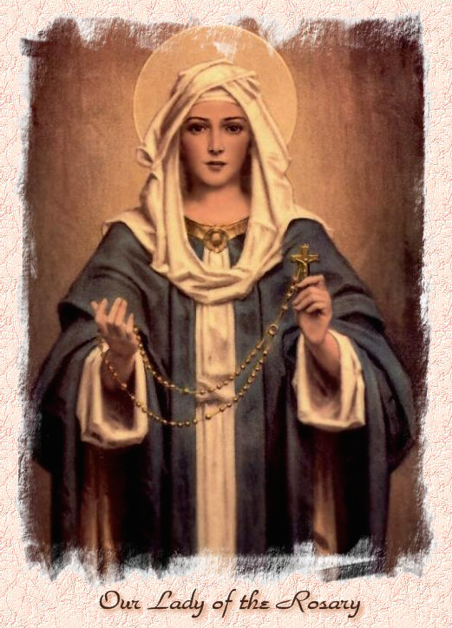

Our Lady of the Rosary  330a Burnt Oak Lane  Blackfen Sidcup  DA15 8LW  Tel. 020 8300 2697  Email: blackfen@rcaos.org.uk  Website: www.rcblackfen.org.uk  (Registered Charity 1173050)  Our Lady of the Rosary Primary School  Tel: 020 8850 4470 | Parish Team  Fr. Biju John  Our Priest  Vicki Rock  Parish Secretary  Office Hours  Mon, Tues, Wed, & Fri  9:00am-12:00pm  Yanet Devis  Website Co-ordinator

MASS TIMES:  SATURDAY VIGIL 6:00pm  SUNDAY 9:00am & 11am  CONFESSIONS:  Friday: 10.30am – 11.00am  Saturday: 5:20pm – 5:50pm  Marriage & Baptism by appointment only.  (Please ring the office to make an appointment) | EXPOSTION OF THE BL SACRAMENT:  Every Friday: 10.30 am to 11.00 am  CHILDREN’S LITURGY GROUP:  Every Sunday at 9am Mass  PRAYER GROUP:  Every Wednesday after 10am Mass  CHOIR PRACTICE:  After the 11am mass on Sunday  UCM:  Every First Tuesday Of the Month at 7.30pm  COFFEE MORNING:  After 11am Mass Sunday & 10am Thursday

Rotas for next week 17th/18th January 2026

Reader | Eucharistic Ministers | Church  Cleaners | Florist | Counters | Repository
Saturday  Pauline  Sunday  9:00am  Angela  11:00am  Angel | Saturday  Jo  Bernadette  Eric  Sunday  9.00am  Christopher  Henry  Chris B  11:00am  Justin  Vicki  Jude | Valerie  Michelle | Margaret  Pat | Louise  Michael | Saturday  Claire  Sunday  9:00am  Lynda  11:00am  Eloise

If you are unable to exercise your ministry, please arrange a replacement
My dear Friends,
This Sunday, we celebrate the Feast of the Baptism of Jesus — a special moment when He sanctified the waters and made us holy. His baptism was also a commissioning for a great mission: to bring us life. Let us be grateful for the gift of life and strive to live as holy children of God, reflecting His love in all we do.
With blessings,
Fr. John

TODAY’S RESPONSE TO PSALM
The Lord will bless his people with peace.
REPONSE TO BIDDING PRAYER
Hear our prayer.
READINGS FOR NEXT SUNDAY
2nd Sunday in Ordinary time
First Reading – Isaiah 49:3, 5-6
Second Reading – Corinthians 1:1-3
Gospel – John 1:29-34

WELCOME TO THE PARISH
You are most welcome to register, either by yourself or with your family, in our parish. May Our Lady intercede for you and your loved ones. Registration and Gift Aid forms are at the back of the Church.
Please introduce yourself to Fr John who will be delighted to welcome you.

January Collections 2026

4/1/26 £549.68 1st Coll

Mass attendance 188

Thank you for your generosity.

Next Week’s 2nd Collection
18th Jan - The work of Pax Christi is based on the Gospel and inspired by faith. Our Vision is of a world where people can live in peace, without fear of violence in all its forms. Rooted in Catholic Christianity, we work with all who share our values to abolish war and create communities of peace and justice. There are gift aid envelopes at the back of the church.
2nd Collections in January
25th Jan – Maintenance of St George’s Cathedral

GIFT AID INFORMATION,
Please remember that if you are a UK taxpayer you can Gift Aid your contribution to the Church. Forms are at the back of the church. Any enquiries, contact Julie at -
blackfengac@rcaos.org.uk. Thank you

PRAYERS FOR THE SICK
Colleen Moulinie, Christopher Browne,
Vivien Lobo, Alison Pearson, Lee Harris, Stella Goodyear, Annie McQuillen, Mairead Rankin, Margaret Bayjou, Snr. Roy Howard, Alice Brand, Laurel, Susanna Brown, Gerard McDonagh, Josephine Treloar, Hilda Strangeway, Vincent Fionda, Howard Smith, Lisa, Morris Lacken, Mick Hannon, Martin McDonagh, Gerald McDonagh and Annie McDonagh.
Please remember them in your prayers.

MASS INTENTIONS
Mass intention are to be booked through the parish office. Anniversary masses should be booked in advance. There are envelopes at the back of the church for this. Please make sure you add your name and phone number in case your requested mass is not available.
Thank you.

Dates This Week
-Youth Club
Wednesday 7pm Social Club
-FHC Class
Sat 17th Jan at 4:40pm

NEWS
Our Church in Need
Our church is in need of an electric votive candle stand. If you are celebrating a birthday, wedding anniversary, or any special occasion in your life, please consider sponsoring this project. Partial sponsorships are also welcome. For more details, please speak to the parish office.
Raffle prizes
There are still a few unclaimed raffle prizes from Christmas. This is the last week to claim the, please check your tickets at home…..Brown ticket 191-195, yellow ticket 136-140, brown ticket 6-10, brown ticket 136-140.
CTiS Are holding a Unity Service on Sunday 18th Jan 4pm, at Sidcup Baptist Church. Everyone is welcome to attend. It would be nice to have some of our parishioners turn up for the service. CTiS comprises of a group of 12 local churches promoting working together to promote mutual understanding and shared beliefs within our local community, see poster in the porch.
Lenten Kickoff Party
Join us on Sunday, 15th February, after the 11 a.m. Mass for a parish get-together before Lent begins. Let’s celebrate together one last time before Easter!
Lent is a season of peace and reflection, so simple festivities are encouraged. Please bring your food and drinks to share as we enter into this joyful time together.
Donations
January 2026, we are planning a joint meeting with the Parish Events Committee and the Fundraising Committee to organise

upcoming parish events and fundraising activities. If you have any ideas for fundraising or events you would like please let the parish office know. In the meantime, if anyone approaches you for donations or gifts on behalf of the parish, please contact the parish office before making any contribution.
Reminder
This is a gentle reminder not to rely on WhatsApp group messages for parish Mass times or other parish information. Please refer only to our official parish website or the parish newsletter for accurate announcements and updates.
Confirmation and RCIA
Thank you to everyone for turning up this week and for your continued support.
If you would like to join either please inform Fr John or the Parish office ASAP.
Padre Pio Prayer Group
Is now back on Wednesdays after 11am mass. Everyone one is welcome to come along and join in with the group.
Catechists & Extra-Ordinary Minister
Could you be a Catechist or a Minister of the Eucharist? If you think you could do this or would like to find out more information contact the parish office or speak to Fr John.
Church Opening
From the beginning February the Church will be open weekday mornings from 9am-12pm for private prayer and reflection.
Please Note
-We have had CCTV installed in the Church, the Sacristy and the Small Hall. This is for security and safety of the parish and the parishioners.
-If you are writing a cheque for the parish/church could you please make it payable to: RCAS Blackfen. Thank you.
Health Care Support
I am a health care/home support. I live in DA15 postcode. If I could be of use to you, please contact me Caroline at carolineejembi@gmail.com.

