Mass Intentions for This Week

Sat  Sun | 17th Jan  18th Jan | 6:00 pm  9:00 am  11:00 am | Holy Souls  Pro Populo  Well-Being of Rock Family
Mon | 19th Jan | 10:00 am | Church Closed
Tue | 20th Jan | 10:00 am | No Mass
Wed | 21st Jan | 10:00 am | Tom Saunders R.I.P  Eucharistic Service
Thu | 22nd Jan | 10:00 am | Roy David Lancaster R.I.P
Fri | 23rd Jan | 10:00 am | Private Intention
Sat  Sun | 24th Jan  25th Jan | 6:00 pm  9:00 am  11:00am | Pro Populo  Holy Souls  Holy Souls

OUR LADY OF THE ROSARY
2nd Sunday in Ordinary Time
PARISH MASS BOOK YEAR A Page 125
Sunday 18th January 2026

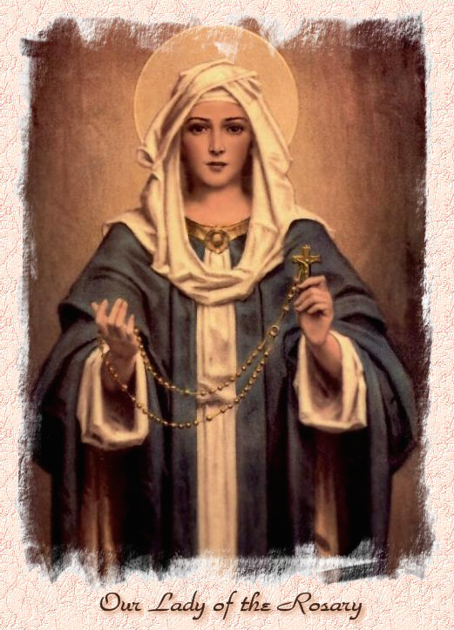

Our Lady of the Rosary  330a Burnt Oak Lane  Blackfen Sidcup  DA15 8LW  Tel. 020 8300 2697  Email: blackfen@rcaos.org.uk  Website: www.rcblackfen.org.uk  (Registered Charity 1173050)  Our Lady of the Rosary Primary School  Tel: 020 8850 4470 | Parish Team  Fr. Biju John  Our Priest  Vicki Rock  Parish Secretary  Office Hours  Mon, Tues, Wed, & Fri  9:00am-12:00pm  Yanet Devis  Website Co-ordinator

MASS TIMES:  SATURDAY VIGIL 6:00pm  SUNDAY 9:00am & 11am  CONFESSIONS:  Friday: 10.30am – 11.00am  Saturday: 5:20pm – 5:50pm  Marriage & Baptism by appointment only.  (Please ring the office to make an appointment) | EXPOSTION OF THE BL SACRAMENT:  Every Friday: 10.30 am to 11.00 am  CHILDREN’S LITURGY GROUP:  Every Sunday at 9am Mass  PRAYER GROUP:  Every Wednesday after 10am Mass  CHOIR PRACTICE:  After the 11am mass on Sunday  UCM:  Every First Tuesday Of the Month at 7.30pm  COFFEE MORNING:  After 11am Mass Sunday & 10am Thursday

Rotas for next week 24th/25th January 2026

Reader | Eucharistic Ministers | Church  Cleaners | Florist | Counters | Repository
Saturday  Jo  Sunday  9:00am  Pauline  11:00am  Becky | Saturday  Joan  Mark  Bernadette  Sunday  9.00am  Carol-Ann  Mateusz  Christopher  11:00am  Bernadette  Romeo  Rafael | Sarah | Pat  Rita | Louise  Ray  Peter | Saturday  Claire  Sunday  9:00am  Sarah  11:00am  Edie

If you are unable to exercise your ministry, please arrange a replacement
My Dear Friends,
This Sunday’s Gospel message is very clear: John the Baptist presents Jesus as the Lamb of God. In every liturgy, we repeat this profound truth: “Lamb of God, you take away the sin of the world, have mercy on us.”
Jesus is the one who takes away the sin of the world. He is the true sacrifice who brings healing, forgiveness, and new life to humanity. Through His self-giving love, our brokenness is redeemed and our hope is restored.
May this truth deepen our faith and draw us closer to Christ, who offers Himself for our salvation.
With prayers and blessings,
Fr. John

TODAY’S RESPONSE TO PSALM
Behold, I have come, Lord, to do your will.
REPONSE TO BIDDING PRAYER
Lord graciously hear us.
READINGS FOR NEXT SUNDAY
3rd Sunday in Ordinary time
First Reading – Isaiah 9:1b-4
Second Reading – Corinthians 1:10-13,17
Gospel – Matthew 4:12-23

WELCOME TO THE PARISH
You are most welcome to register, either by yourself or with your family, in our parish. May Our Lady intercede for you and your loved ones. Registration and Gift Aid forms are at the back of the Church. Please introduce yourself to Fr John who will be delighted to welcome you.

This Week’s 2nd Collection
18th Jan - The work of Pax Christi is based on the Gospel and inspired by faith. Our Vision is of a world where people can live in peace, without fear of violence in all its forms. Rooted in Catholic Christianity, we work with all who share our values to abolish war and create communities of peace and justice. There are gift aid envelopes at the back of the church.

January Collections 2026

11/1/26 £455.59 1st Coll

Mass attendance 167
Thank you for your generosity.

2nd Collections in January
25th Jan – Church Maintenance Fund

GIFT AID INFORMATION,
Please remember that if you are a UK taxpayer you can Gift Aid your contribution to the Church. Forms are at the back of the church. Any enquiries, contact Julie at -
blackfengac@rcaos.org.uk. Thank you.

PRAYERS FOR THE SICK
Colleen Moulinie, Christopher Browne,
Vivien Lobo, Alison Pearson, Lee Harris, Stella Goodyear, Annie McQuillen, Mairead Rankin, Margaret Bayjou, Snr. Roy Howard, Alice Brand, Laurel, Susanna Brown, Gerard McDonagh, Josephine Treloar, Hilda Strangeway, Vincent Fionda, Howard Smith, Lisa, Morris Lacken, Mick Hannon, Martin McDonagh, Gerald McDonagh and Annie McDonagh.
Please remember them in your prayers.

MASS INTENTIONS
Mass intention are to be booked through the parish office. Anniversary masses should be booked in advance. There are envelopes at the back of the church for this. Please make sure you add your name and phone number in case your requested mass is not available.

Dates This Week
-CTiS Unity Service
Sunday 18th 4pm Sidcup Baptist Church
-Prayer Group
Wednesday after 10am Mass
-Youth Club
Wednesday 7pm Social Club
-FHC Class
Sat 24th Jan at 4:40pm

NEWS
Our Church in Need
Our church is in need of an electric votive candle stand. If you are celebrating a birthday, wedding anniversary, or any special occasion in your life, please consider sponsoring this project. Partial sponsorships are also welcome. For more details, please speak to the parish office.
Evangelisation Conference
We really need volunteers to help organise the Evangelisation Conference in June. We are inviting specialists to speak, but need help with all the backround planning. If you are able to help please contact Jayne 07793 884137 or Claire 07958 790057 or come along to our next meeting on Sunday 25th January after 11am mass. Your help will great be apperciated.
Church Opening
From Monday 2nd February the Church will be open weekday mornings from 9am-12pm for private prayer and reflection. Mass will still be 10am.
Lenten Kickoff Party
Join us on Sunday, 15th February, after 11am, mass for a parish get-together before Lent begins. Let’s celebrate together one last time before Easter!
Lent is a season of peace and reflection, so simple festivities are encouraged. Please bring your food and drinks to share as we enter into this joyful time together.
St John Vianney Church
Will be hosting an International Exhibition designed and created by Saint Carlo Acutis from 30th January to 15th February. This is open to all. Please see the poster in the porch for more information. Thank you.
Update from Events -fundraising Committee
We had a very productive meeting on Wednesday with the Event Fundraising Committee.We have planned many important programmes for the coming year. Thank you to all the participants and to the leaders of both committees, Julie and Nicky, for your commitment and hard work. In the coming weeks, we will publish the full list of events and fundraising activities. If you would like to join any of these groups, you are most welcome.
Baptism: If you would like your child to be baptised, please take an application form from the back of the church, complete it, and hand it in to the parish office.This is a joyful moment for you, your child, your family, and our parish community. We truly appreciate your commitment to handing on the faith and nurturing your child in the Catholic faith.
RCIA: sessions are currently in progress. If you would like to refresh or deepen your understanding of the Catholic faith and the sacraments, you are warmly invited to join this group to nurture your faith. Our sincere thanks to our catechists, Alex and Louise, for their time, dedication and commitment.
First Holy Communion and Confirmation: We are in need of more catechists to support our children and young people in their faith journey. If you feel called to serve as a catechist, you are most welcome to join us.
Please do not be concerned about your experience or skills. We will guide and support you, and the Diocese provides excellent resources to help you grow into this ministry. Above all, this is a calling, and the Holy Spirit will guide and strengthen you.
Parish Help and Support – Volunteer Role
We are seeking a kind and committed volunteer who may be able to offer five hours per week to assist with parish office related activities, helping our parish to serve the community more effectively. If you feel you may be able to offer your time and skills in this way, please speak to Fr John.This support is urgently needed from the beginning of February. Thank you for your generosity and continued support of our parish life.
PARISH OFFICE HOURS
The office will be open on Thursday 22nd January and then closed Friday 23rd January till Wednesday 28th January.

