Mass Intentions for This Week

Sat  Sun | 24th Jan  25th Jan | 6:00 pm  9:00 am  11:00 am | Pro Populo  Marcolina Matheus R.I.P  Holy Souls
Mon | 26th Jan | 10:00 am | Church Closed
Tue | 27th Jan | 10:00 am | No Mass
Wed | 28th Jan | 10:00 am | Eucharistic Service
Thu | 29th Jan | 10:00 am | David Meachem R.I.P
Fri | 30th Jan | 10:00 am | No Mass
Sat  Sun | 31st Jan  1st Feb | 6:00 pm  9:00 am  11:00am | Mary Fleming R.I.P  Pro Populo  Tom Saunders R.I.P

OUR LADY OF THE ROSARY
3rd Sunday in Ordinary Time
PARISH MASS BOOK YEAR A Page 125
Sunday 25th January 2026

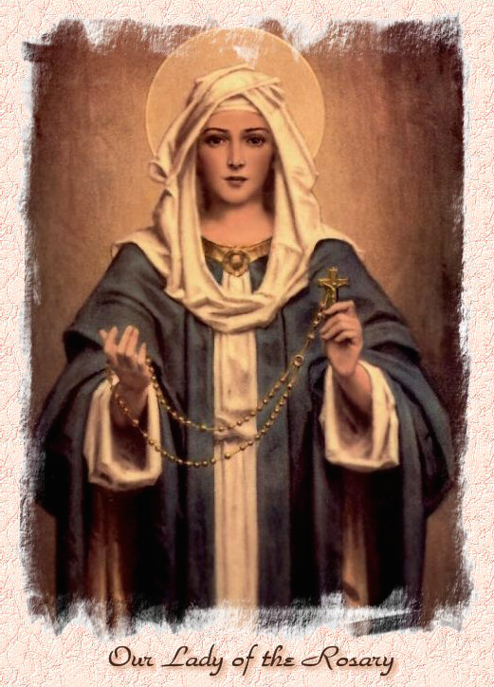

Our Lady of the Rosary  330a Burnt Oak Lane  Blackfen Sidcup  DA15 8LW  Tel. 020 8300 2697  Email: blackfen@rcaos.org.uk  Website: www.rcblackfen.org.uk  (Registered Charity 1173050)  Our Lady of the Rosary Primary School  Tel: 020 8850 4470 | Parish Team  Fr. Biju John  Our Priest  Vicki Rock  Parish Secretary  Office Hours  Mon, Tues, Wed, & Fri  9:00am-12:00pm  Yanet Devis  Website Co-ordinator

MASS TIMES:  SATURDAY VIGIL 6:00pm  SUNDAY 9:00am & 11am  CONFESSIONS:  Friday: 10.30am – 11.00am  Saturday: 5:20pm – 5:50pm  Marriage & Baptism by appointment only.  (Please ring the office to make an appointment) | EXPOSTION OF THE BL SACRAMENT:  Every Friday: 10.30 am to 11.00 am  CHILDREN’S LITURGY GROUP:  Every Sunday at 9am Mass  PRAYER GROUP:  Every Wednesday after 10am Mass  CHOIR PRACTICE:  After the 11am mass on Sunday  UCM:  Every First Tuesday Of the Month at 7.30pm  COFFEE MORNING:  After 11am Mass Sunday & 10am Thursday

Rotas for next week 31st Jan/1st Feb 2026

Reader | Eucharistic Ministers | Church  Cleaners | Florist | Counters | Repository
Saturday  Uche  Sunday  9:00am  Osita  11:00am  Daria | Saturday  Eric  Joan  Mark  Sunday  9.00am  Henry  Chris B  Carol-Ann  11:00am  Justin  Vicki  Jude | Sarah | Edie  Sue | Julie  Jed  Edie | Saturday  Claire  Sunday  9:00am  Lynda  11:00am  Michelle

If you are unable to exercise your ministry, please arrange a replacement
My Dear Friends,
On this Third Sunday, we hear Jesus proclaim the Good News: repentance, forgiveness of sins, and the nearness of the Kingdom of God. As He calls His first disciples, they leave everything behind to follow Him without hesitation. Their response reminds us that the true priority of our lives is to follow Jesus first — and when we place Him at the centre, everything else finds its proper place. May we renew our commitment to walk faithfully in His footsteps each day.
With every blessing,
Fr. John

TODAY’S RESPONSE TO PSALM
The Lord is my light and salvation.
REPONSE TO BIDDING PRAYER
Lord graciously hear us.
READINGS FOR NEXT SUNDAY
4th Sunday in Ordinary time
First Reading – Zephaniah 2:3; 3:12-13
Second Reading – Corinthians 1:26-31
Gospel – Matthew 5:1-12a

WELCOME TO THE PARISH
You are most welcome to register, either by yourself or with your family, in our parish. May Our Lady intercede for you and your loved ones. Registration and Gift Aid forms are at the back of the Church. Please introduce yourself to Fr John who will be delighted to welcome you.

January Collections 2026
18/1/26 £614.76 1st Coll
£153.46 2nd Coll

Mass attendance 252
Thank you for your generosity.
This Week’s 2nd Collection
Church Maintenance Fund – There were gift aid envelopes given out last week for this collection, please use them, as the church can claim an extra 25% on your donation as no extra cost to you through Gift Aid. If you are a UK tax payer please fill in the details. There are more envelopes at the back of the church.
2nd Collections in February
1st Feb – Racial Justice Sunday
8th Feb – St Georges Cathedral Maintenance
15th Feb – Sick & Retired Priests
22nd Feb – Church Maintenance Fund

GIFT AID INFORMATION,
Please remember that if you are a UK taxpayer you can Gift Aid your contribution to the Church. Forms are at the back of the church. Any enquiries, contact Julie at -
blackfengac@rcaos.org.uk. Thank you.

PRAYERS FOR THE SICK
Colleen Moulinie, Christopher Browne,
Vivien Lobo, Alison Pearson, Lee Harris, Stella Goodyear, Annie McQuillen, Mairead Rankin, Margaret Bayjou, Snr. Roy Howard, Alice Brand, Laurel, Susanna Brown, Gerard McDonagh, Josephine Treloar, Hilda Strangeway, Vincent Fionda, Howard Smith, Lisa, Morris Lacken, Mick Hannon, Martin McDonagh, Gerald McDonagh and Annie McDonagh.
Please remember them in your prayers.

MASS INTENTIONS
Mass intention are to be booked through the parish office. Anniversary masses should be booked in advance. There are envelopes at the back of the church for this. Please make sure you add your name and phone number in case your requested mass is not available.

Dates This Week
-Prayer Group
Wednesday after 10am Mass
-Youth Club
Wednesday 7pm Social Club
-FHC Class
Sat 31st Jan at 4:40pm

NEWS
Welcome
We extend a warm welcome to Bishop Pat as he celebrates Mass with us over these days. We are deeply grateful for his kindness and goodwill in supporting our parish.
Church Opening
From Monday 2nd February the Church will be open weekday mornings from 9am-12pm for private prayer and reflection. Mass will still be 10am Tuesday-Friday.
Toddler, Toys & Tea Sunday 8th Feb.
If you have children of pre school age (older sibings can join) come and join us for a get together on Sunday 8th February after 11am mass, till 2pm, for a light lunch tea/coffee and play. No booking needed and no cost.
Lenten Kickoff Party
Join us on Sunday, 15th February, after 11am, mass for a parish get-together before Lent begins. Let’s celebrate together one last time before Easter! Please bring food and drinks to share as we enter into this joyful time together. Lent is a season of peace and reflection, so simple festivities are encouraged.
Our Church in Need
Our church is in need of an electric votive candle stand. If you are celebrating a birthday, wedding anniversary, or any special occasion, please consider sponsoring this. Partial sponsorships is also welcome. For more details, speak to the parish office.
Sacraments:
Baptism: If you would like your child to be baptised, please take an application form from the back of the church, complete it, and hand it in to the parish office.This is a joyful moment for you, your child, your family, and our parish community. We truly appreciate your commitment to handing on and nurturing your child in the Catholic faith.
RCIA: sessions are currently in progress. If you would like to refresh or deepen your understanding of the Catholic faith and the sacraments, you are warmly invited to join this group. Our sincere thanks to our catechists, Alex and Louise, for their time, dedication and commitment.
First Holy Communion and Confirmation: We are in need of more catechists to support our children and young people in their faith journey. If you feel called to serve as a catechist, you are most welcome to join us.
Please do not be concerned about your experience or skills. We will guide and support you, and the Diocese provides excellent resources to help you grow into this ministry. Above all, this is a calling, and the Holy Spirit will guide and strengthen you.
Parish Help and Support – Volunteer
We are seeking a kind and committed volunteer who may be able to offer five hours per week to assist with parish office related activities, helping our parish to serve the community more effectively. If you feel you may be able to offer your time and skills in this way, please speak to Fr John.This support is needed ASAP. Thank you for your generosity and continued support of our parish life.
Safeguarding Matters
All volunteers, catechists, and parish group members must register using the parish volunteer form and complete the DBS process through the parish, in accordance with diocesan and national safeguarding guidelines. Vicki will be in touch to provide the necessary link to begin the application.
Fundraising and Events
You are most welcome to be part of any of our fundraising or events groups. If you have any fundraising ideas or would like to get involved, please contact the fundraising or events team leaders via the parish office.
In the coming weeks, we will publish the full list of events and fundraising activities. If you would like to join any of these groups, you are warmly encouraged to participate.
PARISH OFFICE HOURS
The office will be closed Mon/Tues/Wed this week. It will however be open on Thurs 29th & Fri 30th 9am-12pm.

