Mass Intentions for This Week

Sat  Sun | 3rd Jan  4th Jan | 6:00 pm  9:00 am  11:00 am | Pro Populo  Holy Souls  Jeff Turner R.I.P
Mon | 5th Jan | 10:00 am | Church Closed
Tue | 6th Jan | 10:00 am  7:00 pm | Well-being of Daniel Guilliford  Holy Souls
Wed | 7th Jan | 10:00 am | Lucy DeFreitas R.I.P
Thu | 8th Jan | 10:00 am | Pat, Tina & Anie 70th Birthday
Fri | 9th Jan | 10:00 am | Rina & Ugo Martinelli R.I.P
Sat  Sun | 10th Jan  11th Jan | 6:00 pm  9:00 am  11:00am | Well-being of the Moulinie Family  Joan & Don Trill R.I.P  Pro Populo

OUR LADY OF THE ROSARY
2nd Sunday after the Nativity
PARISH MASS BOOK YEAR A Page 111
Sunday 4th January 2026

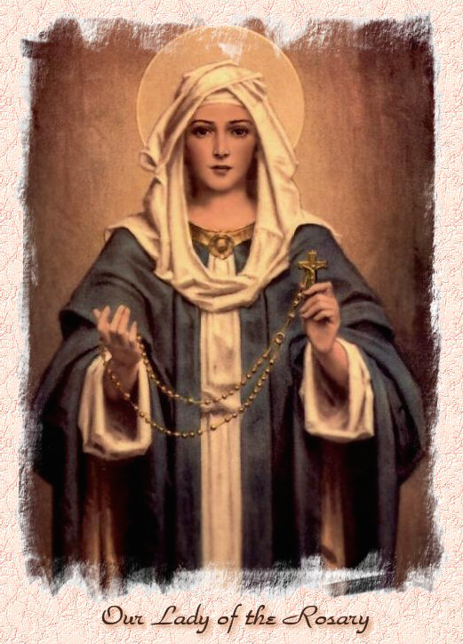

Our Lady of the Rosary  330a Burnt Oak Lane  Blackfen Sidcup  DA15 8LW  Tel. 020 8300 2697  Email: blackfen@rcaos.org.uk  Website: www.rcblackfen.org.uk  (Registered Charity 1173050)  Our Lady of the Rosary Primary School  Tel: 020 8850 4470 | Parish Team  Fr. Biju John  Our Priest  Vicki Rock  Parish Secretary  Office Hours  Mon, Wed, & Fri  9:00am-12:00pm  Yanet Devis  Website Co-ordinator

MASS TIMES:  SATURDAY VIGIL 6:00pm  SUNDAY 9:00am & 11am  CONFESSIONS:  Friday: 10.30am – 11.00am  Saturday: 5:20pm – 5:50pm  Marriage & Baptism by appointment only.  (Please ring the office to make an appointment) | EXPOSTION OF THE BL SACRAMENT:  Every Friday: 10.30 am to 11.00 am  CHILDREN’S LITURGY GROUP:  Every Sunday at 9am Mass  PRAYER GROUP:  Every Wednesday after 10am Mass  CHOIR PRACTICE:  After the 11am mass on Sunday  UCM:  Every First Tuesday Of the Month at 7.30pm  COFFEE MORNING:  After 11am Mass Sunday & 10am Thursday

Rotas for next week 10th/11th January 2026

Reader | Eucharistic Ministers | Church  Cleaners | Florist | Counters | Repository
Saturday  Bernadette  Sunday  9:00am  Margaret B  11:00am  sue | Saturday  Eric  Joan  Mark  Sunday  9.00am  Chris B  Carol-Ann  Mateusz  11:00am  Bernadette  Romeo  Rafael | Nikki  Mary | Edie  Sue | Maura  Sarah  Breitner | Saturday  Claire  Sunday  9:00am  Sarah  11:00am  Valerie

If you are unable to exercise your ministry, please arrange a replacement
Dear Friends
This week we celebrate the Feast of the Epiphany, a word that means appearance or manifestation. It marks the first revelation of Jesus to the Gentiles, represented by the Magi who came from distant lands seeking the newborn King.
Every appearance of Jesus throughout the Gospels points to one profound truth: “The Word became flesh and lived among us.” The term translated in many Bibles as lived—or dwelt in older translations—literally means pitched His tent or encamped. In other words, “The Word became flesh and encamped among us.”
As we begin this New Year, let us invite Jesus to encamp in our hearts, in our families, and in our parish community. When He dwells among us, His presence brings peace—peace in our homes, peace in our relationships, and peace in our daily lives.
May the Lord who manifested Himself to the world renew His presence in each of us throughout this New Year.

Thank you very much for your Christmas gifts, donations, and cards. I am deeply grateful for all the hard work that made our Christmas celebrations so beautiful.
A special word of thanks to:
The First Holy Communion children, parents, and catechists for the wonderful Nativity organised on the evening of the 24th.
The Choir, Jayne, and the whole team for the uplifting music.
The Flower Ladies, Margaret and team for the beautiful floral arrangements.
The Altar Servers and Raphael and team for preparing the crib.
Our sacristan, Christine, for her dedicated service.
The Knights of Columbus, Gerard and team, for their support.
The UCM members and the Padre Pio Prayer Group for their contributions.
Nikki and the church-cleaning team, for keeping our church spotless.
Everyone involved in the coffee morning and all who helped in any way.
Thank you to each and every one of you. Your dedication, generosity, and service have been a great blessing to our parish community.
God Bless Fr John

TODAY’S RESPONSE TO PSALM
The word became flesh and dwelt among us.
REPONSE TO BIDDING PRAYER
Lord graciously hear us.
READINGS FOR NEXT SUNDAY
Baptism of the Lord
First Reading – Isaiah 42:1-4,6-7
Second Reading – Acts 10:34-38
Gospel – Matthew 3:13-17

ARE YOU NEW IN THE PARISH?
Hello & Welcome!!!
Please register yourselves and your family. Registration and Gift Aid forms are at the back of the Church. Please introduce yourself to Fr John who will be delighted to welcome you.

December Collections 20225

21/12/25 £565.67 1st Coll
Mass attendance 213
28/12/25 £476.14 1st Coll
Mass attendance 174

Dona machine December £243.00

Thank you for your generosity.

GIFT AID INFORMATION,
Please remember that if you are a UK taxpayer you can Gift Aid your contribution to the Church. Forms are at the back of the church. Any enquiries, contact Julie at -
blackfengac@rcaos.org.uk. Thank you

PRAYERS FOR THE SICK
Colleen Moulinie, Christopher Browne,
Vivien Lobo, Alison Pearson, Lee Harris, Stella Goodyear, Annie McQuillen, Mairead Rankin, Margaret Bayjou, Snr. Roy Howard, Alice Brand, Laurel, Susanna Brown, Gerard McDonagh, Josephine Treloar, Hilda Strangeway, Vincent Fionda, Howard Smith, Lisa, Morris Lacken, Mick Hannon, Martin McDonagh, Gerald McDonagh and Annie McDonagh.
Please remember them in your prayers.

MASS INTENTIONS
Mass intention are to be booked through the parish office. Anniversary masses should be booked in advance. There are envelopes at the back of the church for this. Please make sure you add your name and phone number in case your requested mass is not available.
Thank you.

Dates This Week
-Epiphany 6th Jan
Mass at 10am & 7pm
-Confirmation Registration
8th Jan at 7:30pm
-Yoga
Wednesday 7pm
-FHC Class
Sat 10th Jan at 4:40pm

NEWS
Epiphany
We celebrate the Feast of the Epiphany on Tuesday, 6th January, which is a Holy Day of Obligation. After this feast, all Christmas decorations are traditionally taken down. The Epiphany is one of the most important feasts of the Church, marking the revelation of Christ to the nations. Mass at 10am & 7pm.
Confirmation and RCIA
Please enrol your names as soon as possible.
Confirmation 2026
Registration for candidates and parents will take place on Thursday 8th January 7:30pm.
Carol Concert
The concert and raffle raised £287.74 for the parish. Thank you to everyone involved from organising to attending, you all made it a special occasion. There are still a few unclaimed raffle prizes…..Brown ticket 191-195, yellow ticket 136-140, brown ticket 6-10, yellow ticket 76-80, brown ticket 136-140.
Christmas Stars & Hearts
These raised £38.00. Thank you to everyone who bought one.
Donations
In January 2026, we are planning a joint meeting with the Parish Events Committee and the Fundraising Committee to organise upcoming parish events and fundraising activities. In the meantime, if anyone approaches you for donations or gifts on behalf of the parish, please contact the parish office before making any contribution.
Reminder
This is a gentle reminder not to rely on WhatsApp group messages for parish Mass times or other parish information. Please refer only to our official parish website or the parish newsletter for accurate announcements and updates.
Please Note
-We have had CCTV installed in the Church, the Sacristy and the Small Hall. This is for security and safety of the parish and the parishioners.
-If you are writing a cheque for the parish/church could you please make it payable to: RCAS Blackfen. Thank you.
Health Care Support
I am a health care/home support. I live in DA15 postcode. If I could be of use to you, please contact me Caroline at carolineejembi@gmail.com.

