Mass Intentions for This Week

Sat  Sun | 31st Jan  1st Feb | 6:00 pm  9:00 am  11:00 am | Mary Fleming R.I.P  Pro Populo  Tom Saunders R.I.P
Mon | 2nd Feb | 10:00 am | Church Closed
Tue | 3rd Feb | 10:00 am | No Mass
Wed | 4th Feb | 10:00 am | Des Cunningham R.I.P  Eucharistic Service
Thu | 5th Feb | 10:00 am | Anthony Canavan R.I.P
Fri | 6th Feb | 10:00 am | Kim Dempsey R.I.P
Sat  Sun | 7th Feb  8th Feb | 6:00 pm  9:00 am  11:00am | Pro Populo  Susan Nugent R.I.P  Deceased Relatives of McInerney Family

OUR LADY OF THE ROSARY
4th Sunday in Ordinary Time
PARISH MASS BOOK YEAR A Page 130
Sunday 1st February 2026

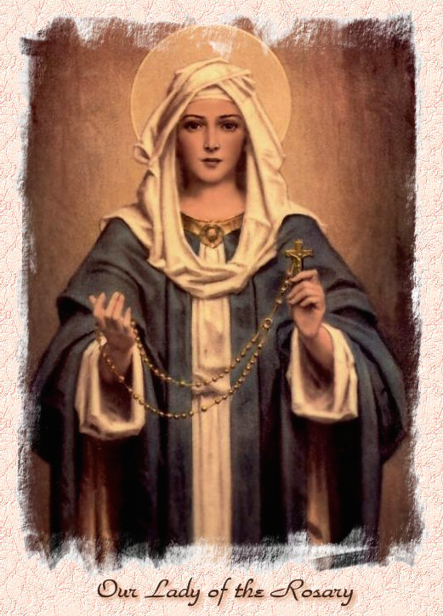

Our Lady of the Rosary  330a Burnt Oak Lane  Blackfen Sidcup  DA15 8LW  Tel. 020 8300 2697  Email: blackfen@rcaos.org.uk  Website: www.rcblackfen.org.uk  (Registered Charity 1173050)  Our Lady of the Rosary Primary School  Tel: 020 8850 4470 | Parish Team  Fr. Biju John  Our Priest  Vicki Rock  Parish Secretary  Office Hours  Mon, Tues, Wed, & Fri  9:00am-12:00pm  Yanet Devis  Website Co-ordinator

MASS TIMES:  SATURDAY VIGIL 6:00pm  SUNDAY 9:00am & 11am  CONFESSIONS:  Friday: 10.30am – 11.00am  Saturday: 5:20pm – 5:50pm  Marriage & Baptism by appointment only.  (Please ring the office to make an appointment) | EXPOSTION OF THE BL SACRAMENT:  Every Friday: 10.30 am to 11.00 am  CHILDREN’S LITURGY GROUP:  Every Sunday at 9am Mass  PRAYER GROUP:  Every Wednesday after 10am Mass  CHOIR PRACTICE:  After the 11am mass on Sunday  UCM:  Every First Tuesday Of the Month at 7.30pm  COFFEE MORNING:  After 11am Mass Sunday & 10am Thursday

Rotas for next week 7th/8th Feb 2026

Reader | Eucharistic Ministers | Church  Cleaners | Florist | Counters | Repository
Saturday  Sally  Sunday  9:00am  Henry  11:00am  Claire | Saturday  Bernadette  Eric  Joan  Sunday  9.00am  Mateusz  Christopher  Chris B  11:00am  Bernadette  Romeo  Rafael | Nikki  Mary | Margaret  Rita | Maura  Sarah  Breitner | Saturday  Claire  Sunday  9:00am  Lynda  11:00am  Michelle

If you are unable to exercise your ministry, please arrange a replacement
My Dear Friends,
This Sunday we hear the Beatitudes, where Jesus proclaims: “Blessed are the poor in spirit, for theirs is the kingdom of heaven.” This is a call to live with humility of heart — recognising our dependence on God and learning to accept one another in love, so that we may live in harmony and peace.
At present, as I am travelling in the Caribbean, this time of rest has also become an opportunity to reflect on possibilities for charity and service. What strikes me here is the deep sense of harmony — between people, nature, and community life. The annual hurricanes remind everyone of their interdependence: people rely on one another for survival, recovery, and hope. It becomes a powerful lesson that we truly belong to one human family.
In our modern, often self-sufficient lifestyles, we can easily forget this eternal truth. The Beatitudes gently call us back to humility, gratitude, and compassion. God invites every human heart to live in a spirit of simplicity, trust, peace, and mutual care; the true poverty of spirit that opens us to the Kingdom of God.
With every blessing,
Fr. John

TODAY’S RESPONSE TO PSALM
Blessed are the poor in spirit; for theirs is the kingdom of heaven.
REPONSE TO BIDDING PRAYER
Lord graciously hear us.

READINGS FOR NEXT SUNDAY
5th Sunday in Ordinary time
First Reading – Isaiah 58:6-10
Second Reading – 1 Corinthians 2:1-5
Gospel – Matthew 5:13-16
WELCOME TO THE PARISH
You are most welcome to register, either by yourself or with your family, in our parish. May Our Lady intercede for you and your loved ones. Registration and Gift Aid forms are at the back of the Church. Please introduce yourself to Fr John who will be delighted to welcome you.

January Collections 2026
25/1/26 £500.38 1st Coll
£340.58 2nd Coll

Mass attendance 235
Thank you for your generosity.

This Week’s 2nd Collection
Catholic Association for Racial Justice
Support the work of the Catholic Church to promote racial justice in our schools, parishes and in wider society.
2nd Collections in February
8th Feb – St Georges Cathedral Maintenance
15th Feb – Sick & Retired Priests
22nd Feb – Church Maintenance Fund

GIFT AID INFORMATION,
Please remember that if you are a UK taxpayer you can Gift Aid your contribution to the Church. Forms are at the back of the church. Any enquiries, contact Julie at -
blackfengac@rcaos.org.uk. Thank you.

PRAYERS FOR THE SICK
Colleen Moulinie, Christopher Browne,
Vivien Lobo, Alison Pearson, Lee Harris, Stella Goodyear, Annie McQuillen, Mairead
Rankin, Margaret Bayjou, Snr. Roy Howard, Alice Brand, Laurel, Susanna Brown, Gerard McDonagh, Josephine Treloar, Hilda Strangeway, Vincent Fionda, Howard Smith, Lisa, Morris Lacken, Mick Hannon, Martin McDonagh, Gerald McDonagh and Annie McDonagh.
Please remember them in your prayers.

MASS INTENTIONS
Mass intention are to be booked through the parish office. Anniversary masses should be booked in advance. There are envelopes at the back of the church for this. Please make sure you add your name and phone number in case your requested mass is not available.

Dates This Week
-Prayer Group
Wednesday after 10am Mass
-Youth Club
Wednesday 7pm Social Club
-FHC Class
Sat 7th at 4:40pm

NEWS
Thanks
Thank you Bishop Pat for covering masses for us while Fr John is away.
Fundraising
We have 2 sponsored events going on over the next few months, Fundraising for the parish.
10km Run/Walk Saturday 21st March Avery Hill Park
To participate in this fundraising event please register yourself, fee of £5 or if you don’t feel that brave, please sponsor those taking part in the challenge. Speak to Claire or see the team outside church before/after Sunday Masses. Sponorship can be made outside church or you can use the contactless machine under 10k Run/Walk.
50k Bike Ride Saturday 9th May
Parishioner Kelly Disson is doing a 50k bike ride in May to raise money for the parish. You can donate to her JustGiving page at
https://share.google/ShomOP7memyUnB945or search Kelly Disson- Archdiocese of Southwark. There will be a box for cash donations outside of church.
Church Opening from Monday 2nd February the Church will be open weekday mornings from 9am-12pm for private prayer and reflection. Mass will still be 10am Tuesday-Friday.

Toddler, Toys & Tea Sunday 8th Feb.
If you have children of pre school age (older sibings can join) come and join us for a get together on Sunday 8th February after 11am mass, till 2pm, for a light lunch tea/coffee, play & Chat. No booking/no cost.
Lenten Kickoff Party
Join us on Sunday, 15th February, after 11am, mass for a parish get-together before Lent begins. Let’s celebrate together one last time before Easter! Please bring food and drinks to share as we enter into this joyful time together. Lent is a season of peace and reflection, so simple festivities are encouraged.
Ash Wednesday 18th February
Ash Wenesday is a Holy Day of Obligation. There will be 2 masses in the parish that day at 10am & 7pm.
Our Church in Need
Our church is in need of an electric votive candle stand. If you are celebrating a birthday, wedding anniversary, or any special occasion, please consider sponsoring this. Partial sponsorships is also welcome. For more details, speak to the parish office.
Fundraising and Events
You are most welcome to be part of any of our fundraising or events groups. If you have any fundraising ideas or would like to get involved, please contact the Fundraising or Events team leaders via the parish office.
This week pick up a copy of the Events & Fundraising Newsletter January 2026.
Safeguarding
All Volunteers, Catechists and Parish Group members must be registered with the parish using a Parish Volunteer Form, in accordance with Diocesan and national guidelines. If you need to fill in one I will be in touch over the next fews weeks, to provide the necessary links to begin the application. Once you receive the link if you could fill in the electronic form asap that would be helpful. If you have any problems whilst doing this you can always contact me. Thank you for your understanding and help whilst we set this up. Vicki.

