
OUR LADY OF THE ROSARY
330 A, Burnt Oak Lane,
Blackfen, Sidcup, DA 15 8LW
(Registered Charity 1173050)
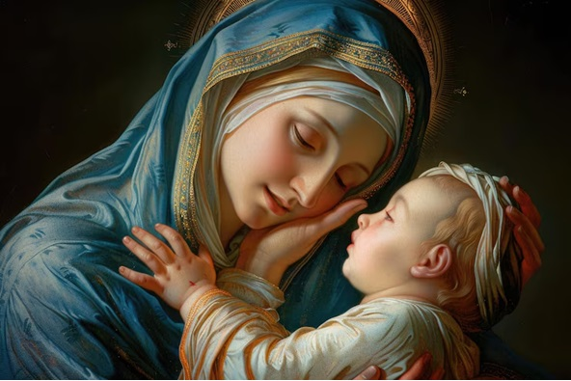

www.rcblackfen.org.uk
Email: blackfen@rcaos.org.uk
Tel: 020 83002697

Our Lady of the Rosary Primary School, Tel: 020 8850 4470

WELCOME TO THE PARISH May Our Lady intercede for you and your loved ones.

Mass Times: Tues-Fri: 10.a.m
Saturday Vigil: 6 p.m.
Sunday: 9 a.m. & 11 a.m.
Confession: Friday 10:30am - 11am
Saturday 5:20pm-5:50pm
Sunday 15th February 2026
6th Sunday in Ordinary Time
Mass book page 136

A WORD FROM FR. JOHN

This Sunday’s readings invite us to reflect on God’s will and the gift of human freedom. God has written his law deep within every human heart, and our freedom exists so that we may freely choose to live according to that law. Yet, because of the hardness of the human heart, the law was given through Moses. Even then, humanity failed to live it fully.
In Jesus, the final revelation, the law reaches its fulfilment. He does not abolish the law; he embodies it through self-giving love, offering his life for the salvation of the world. Love, lived to the end, becomes the perfect fulfilment of the law.
Let us, then, fulfil the law by loving one another, making God’s love visible through acts of charity.
With Every blessing,
PARISH TEAM
Parish Priest: Fr. John
Parish Secretary: Vicki Rock
Finance Chair: Julie Donnelly
Sacristan: Christine Basquil
SAFEGURADING TEAM
Hayley Palmer
Jayne Smith
Louise Davis
Vicki Rock

Fr. John

THE CHURCH IS OPEN

Mon - Fri 9 a.m. to 12 p.m. for private prayer
and reflection.
Parish office Hours: Mon-Wed & Fri: 9am-12pm

EXPOSITION & PRAYER
Exposition of the Blessed Sacrament:
MASS INTENTION
Sat 14th Feb 6pm – Mark Grover R.I.P
Sun 15th Feb 9am – Pro Populo
11am – Reidy Family R.I.P
Mon 16th Feb – No Mass
Tues 17th Feb 10am – Kelly Patel Well-being
Wed 18th Feb 10am – Anthony Canavan R.I.P
Thurs 19th Feb 10am – Peg & Tim O’Sullivan R.I.P
Fri 20th Feb 10am – Holy Souls (Mary Quilty)
7pm – Station of the Cross
Sat 21st Feb 6pm – Pro Populo
Sun 22nd Feb 9am – Andrew Tungdim Birthday
11am – Christine Daisi 2nd Birthday
Fri 10:30am-11am
Rosary: Tues-Fri before 10am mass
Divine Mercy: Friday
Other Devotions: Padre Pio Wed after 10am Mass

CHILDREN LITURGY: 9am Sunday
CHOIR PRACTICE: after 11am mass Sunday
UCM: 1st Tues of Month 7:30pm
KNIGHTS OF ST COLUMBA: 2nd Tues of month 8pm
COFFEE MORNING: after mass Thursday & Sunday
WELCOME TO THE PARISH  Whether you are new or just visiting Welcome. Please introduce yourself to Fr John who will be delighted to welcome you to the Parish.  You are most welcome to register, either by yourself or with your family, in our parish. Registration and Gift Aid forms are at the back of the Church.  PRAYERS FOR THE SICK  Colleen Moulinie, Christopher Browne,  Vivien Lobo, Alison Pearson, Lee Harris, Stella Goodyear, Annie McQuillen, Mairead  Rankin, Margaret Bayjou, Snr. Roy Howard, Alice Brand, Laurel, Susanna Brown, Gerard McDonagh, Josephine Treloar, Hilda Strangeway, Vincent Fionda, Howard Smith, Lisa, Morris Lacken, Mick Hannon, Martin McDonagh, Gerald McDonagh and Annie McDonagh.  Please remember them in your prayers.  Responsorial Psalm  Blessed are those who walk in the law of the Lord!  Response to Bidding Prayer’s  Hear our prayer.  Reading’s for next Sunday  1st Sunday of Lent  First Reading – Genesis 2:7-9, 3:1-7  Second Reading – Romans 5:12-19  Gospel – Matthew 4:1-11  GIFT AID Information  Please remember that if you are a UK taxpayer you can Gift Aid your contribution to the Church. Forms are at the back of the church. Any enquiries, contact Julie at -  blackfengac@rcaos.org.uk. Thank you.  Mass collections can now be found on the noticeboard.  MASS INTENTIONS  Mass intention are to be booked through the parish office. Anniversary masses should be booked in advance. There are envelopes at the back of the church for this. Please make sure you add your name and phone number in case your requested mass is not available. Thank you. Vicki.  Toddler Toys & Tea was last Sunday. A fun time was had by the children. This will now run monthly, so please keep an eye on the newsletter for the next date. Thank you to Nikki, Sarah, Carol-Ann, Julie & Margaret T for organizing and their hard work.  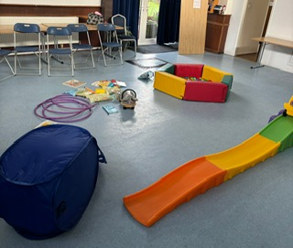 | NEWS & EVENTS  The first Lenten Talk will take place on the 6th March and will be led by Bishop Pat. The evening will begin at 5.00 p.m. with Lenten soup and a roll, followed by the Stations of the Cross. The talk will begin at 6.30 p.m., and Holy Mass will be celebrated at 7.00 p.m. Please note this in your diary. Even if you are working, you may still be able to take time off to join us. Lent is a holy, grace-filled, and fruitful time of the year. Let us journey together in peace and joy. There is a list on the noticeboard if you intend to come please add your name so we have an idea of numbers. Thank you.  Lent Collection  A Lent collection box has been placed at the front of the church. You are invited to contribute from your Lenten sacrifices—for example, by giving up a cup of coffee, a sweet, or something similar. A small sacrifice from each of us can lead to something meaningful.  This collection will help cover some of the expenses during Lent, such as soup and roll evenings, talks, and other Lenten activities.  Lent Reading  Fr. John has republished the book God Walks with Humanity. This book offers scientific and rational explanations for belief in God and briefly reflects on the meaning of suffering, our life journey, and faith.  It is an excellent gift for anyone who has doubts, questions about God, or wishes to deepen their belief. All proceeds from the sale of this book go to a charity that Fr. John has supported for many years.  The book is available to purchase from our repository.  Church in Need  Our church is in need of an electric votive candle stand. If you are considering sponsoring this, please contact the parish office.  Safeguarding in Our Parish  We have a Safeguarding Team in our parish. Their responsibility is to support the parish and ensure that our church is a safe place to worship, participate in the liturgy, and take part in all other church activities.  They work to create a safe and welcoming environment where everyone can share in joy and happiness.  A safe parish is a loving parish.  St Patrick’s Day Celebration – 17th (Tuesday)  We will celebrate St Patrick’s Day on Tuesday the 17th with Irish dancing and finger food. The event will be held in the Main Hall.  All are warmly welcome.  Fundraising  We have 2 sponsored events going on over the next few months, Fundraising for the parish.  10km Run/Walk Saturday 21st March Avery Hill Park  To participate in this fundraising event please register yourself, fee of £5 or if you don’t feel that brave, please sponsor those taking part in the challenge. Speak to Claire or see the team outside church before/after Weekend Masses. Sponsorship can be made outside church or you can use the contactless machine under 10k Run/Walk.  50k Bike Ride Saturday 9th May  Parishioner Kelly Disson is doing a 50k bike ride in May to raise money for the parish. You can donate to her JustGiving page at  https://share.google/ShomOP7memyUnB945 or search Kelly Disson- Archdiocese of Southwark.  Thank you  to the coffee mornings ladies. This week they have donated Thursday £160 & Sunday £120. Thank you for your time & effort.

